FPF:UCJAP028 Výstavba textu

FINAL TEST 2020 Name: __________________
UČO: ___________________

Deadline: Wednesday 29 April 2020 midnight, submission online (odvezdávárna in IS).
Write your answers into the sheet (the space available here can be extended). Upload the finished file online.
_________________________________________________________________________________

1. What is the difference between cohesion and coherence?

2. Describe the various kinds of cohesion.

3. Schemas and scripts as macro-level coherence. Explain and give an example.

4. Discuss the various dimensions of context.

5. Discuss the issue of authenticity in ELT classroom texts.

6. Describe some text adaptation/processing strategies in language teaching.

7. Write the correct answer (true / false)
In comparison with Czech, English tends to:
use more sentence condensers
use the passive voice more frequently
use less parataxis
place rhematic elements at the end of the sentence more often
preserve the same subject in consecutive sentences more often
place the grammatical subject in clause-initial positions more often

8. Identify and describe typical features of spoken language in the passage below:
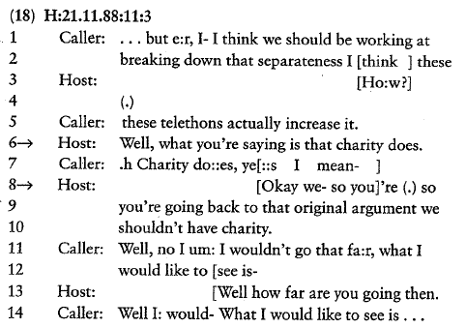

9. Identify cohesive elements (of various kinds) in the text below.
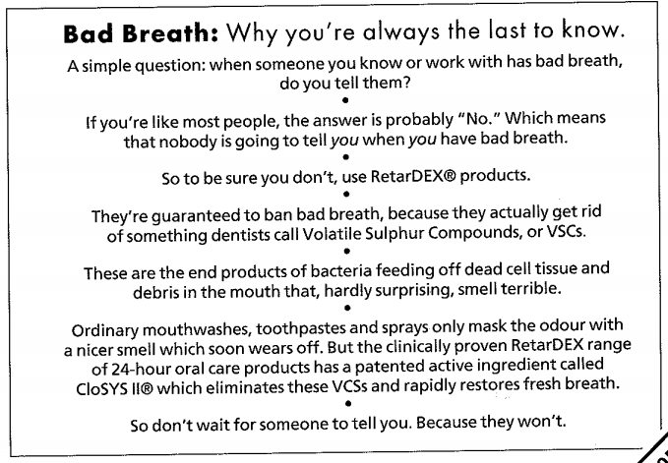

10. Go to www.guardian.co.uk and find a news article published today or yesterday.
Briefly describe 5 ways how you could use the text for teaching English. Explain your reasoning and motivation for choosing those activities. You can copy sections of the text, give examples, etc.

Article headline:
Link:
1
2
3
4
5

11. Create a concrete, full activity that would teach a specific feature/function/construction from the above text. Specify a relevant pedagogical goal and use the text adequately for that purpose.

