A fictional narrative presents an imaginary narrator's account of a story that happened in an imaginary world. A fictional narrative is appreciated for its entertainment and educational value, possibly also for providing a vision of characters that might exist or might have existed, and a vision of things that might happen or could have happened. Although a fictional narrative may freely refer to actual people, places and events, it cannot be used as evidence of what happened in the real world.
A nonfictional narrative (factual narrative) presents a real-life person´s account of a real-life story. Unless there are reasons for questioning an author´s credibility, a factual narrative can serve as evidence of what happened in the real world.

Classification of genres

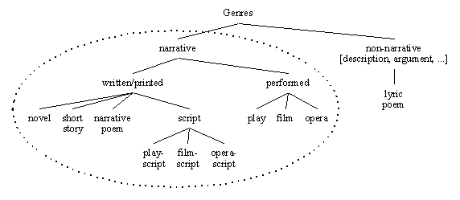
Genres are further divided into sub-genres. Literature can be organized according to the poetic genres and the prose genres.
Poetry is subdivided into epic, lyric, and dramatic.
Prose is subdivided into fiction and non-fiction.
Plays are subdivided into comedy, tragedy, melodrama, etc. Each subgenre can have further subdivisions, e.g., comedy has its own genres: farce, comedy of manners, burlesque, and satire.

Types of Prose Fiction

The novel is longer prose fiction, usually consisting of more than 50,000 words. The novel has become popular at the beginning of the 18th century. The term denotes a prose narrative about characters and their actions.
Flash fiction is prose under a thousand words.
A short story consists of 10,000 to 20,000 words, but it can contain more than 500 words.
A story containing between 20,000 and 50,000 is a novella.
Epistolary novel is a novel in letters. (e.g. Samuel Richardson, Pamela.)
A picaresque novel tells stories and adventures of a picaro (rogue). It consists of episodes that together form a journey of the protagonist who struggles against society, masters of just fate. Examples: Cervantes - Don Quixote; and in the English tradition: Mark Twain - The Adventures of Huckleberry Finn; Daniel Defoe - Moll Flanders.
The historical novel retells some historical event, the setting and characters are historical, usually blends facts and fiction. Examples: Walter Scott - Ivanhoe; Charles Dickens - A Tale of Two Cities.
The bildungsroman (novel of initiation) concentrates on the mental development of the character, changing from a child to an adult. Examples: Henry Fielding - Tom Jones; Charles Dickens - David Copperfield; James Joyce - A Portrait of the Artist as a Young Man.
The gothic novel became popular in the second half of the 18^{th.} century. It should evoke fear, the setting often includes ruins, damaged landscapes, swamps, medieval castles with dungeons. The atmosphere is gloomy, madness and strange voices appear. There are often supernatural forces, demons, or monsters. Examples are Horace Walpole - The Castle of Otranto; Ann Radcliffe - Mysteries of Udolpho; William Faulkner - Absalom! Absalom!
Satire: is usually very funny, but its main aim is to criticize an individual or society.
Crime fiction: deals with crimes, criminals, and their motives.
Detective fiction: concentrates on the investigation of a crime by a detective, either professional or amateur. A common feature is an investigator who is unmarried and has a less intelligent assistant.
Autobiography: biography of oneself narrated by oneself.

Popular genres:

Fantasy: it uses magic and supernatural forms as a primary element of plot, theme and setting.
Horror: has a morbid, gruesome, surreal, or exceptionally suspenseful or frightening theme, includes some kind of evil.
Science fiction: the narrative world differs from or own present or historical reality in at least one significant way. The difference may be technological, physical, historical, sociological, philosophical, metaphysical, etc., but not magical.
Thriller: it is characterized by fast pacing, frequent action, and resourceful heroes fighting against more powerful and better equipped villains. The main characters include law enforcement officers, spies, soldiers, seamen, or pilots.
Western: it is an American genre devoted to telling stories set in the 19th century American West (sometimes Mexico, Canada or Australia, during the same period). It often portrays the conquest of the wilderness and the subordination of nature, or the confiscation of the territorial rights of the original inhabitants of the frontier.

