Unit 5
Learning Objectives
You will learn the basics of proofreading and the way to ensure the translation is correct concerning facts in the translation and terminology.

Keywords
- proofreading, correcting, terminology, factual correctness

One of the most important aspects of the translator’s job is the management of terminology: being exposed to it, evaluating its correctness or appropriateness in specific contexts, storing and retrieving it. Terminology is most easily learned (i.e., stored in memory so as to facilitate later recall) in context—in actual use-situations, in which the people who use such terms in their daily lives are talking or writing to each other.
Terminology is concerned with the naming of concepts in specialized fields of knowledge, e.g. medicine, law, business, chemistry, etc. It has very close ties to other areas of applied linguistics, including specialized translation.
Notions of terminology: concept, definition and term.
Concepts are units of thought that are used to organize our knowledge and perceptions of the world around us. We understand concepts in relation to other concepts, in a structured system. Once it has been identified, it is necessary to define a concept. This definition is what provides a bridge between the concept and the term that is used to designate it.
A terminological definition must be as detailed as is necessary to differentiate a concept and its associated term from other concept term units.
Terms are the linguistic designations assigned to concepts referring to the conceptual entities, properties, activities or relations that constitute knowledge in a particular field.
(Baker, Mona, Gabriela Saldanha, Eds. Routledge Encyclopaedia of Translation Studies. Abingdon: Routledge, 1998.)
Here are some examples of medical terminology with definitions and Czech translation:

Anaemia: reduction in red blood cells which can make the skin pale and cause weakness or breathlessness (anémie)
Anaphylactic reaction: serious allergic reaction which causes difficulty in breathing or dizziness (anafylaktická reakce)
Arrhythmia: irregular heart beat (arytmie)
Cerebrovascular accident: stroke (cévní mozková příhoda)
Colitis: inflammation which causes abdominal pain or diarrhoea (kolitida)
Convulsion or seizure: fit (záchvat)
Dyspepsia: indigestion (dispepsie)
Haemorrhage: bleeding (krvácení)
Hypertension: high blood pressure (hypertenze)
Insomnia: difficulty in sleeping (insomnie)
Jaundice: yellowing of the skin or whites of the eyes caused by liver or blood problems (žloutenka)
Myocardial infarction: heart attack (infarkt myokardu)
Nausea: feeling sick (nevolnost)
Pneumonitis: inflammation of the lungs which causes breathlessness, cough and raised temperature (pneumonie)
Tachycardia: faster heart beat (tachykardie)
Vertigo: a feeling of dizziness or “spinning” (závrať)
TASK 1: Comprehension check:
Read the definitions below and fill in the correct term in Czech.
1. faster heart beat -
2. yellowing of the skin -
3. serious allergic reaction -
4. inflammation of the lungs -
5. high blood pressure -

Theory of terminology:
Concepts, definitions and terms provide the foundation for a theory of terminology.
Knowledge of theories of terminology is important to carry out tasks such as:
- determining relationships between concepts
- dealing with situations where concepts are similar rather than identical
- creating target language terms for new concepts
- finding terms that correspond to the same concept in two languages, which sometimes involves selecting one term from among a number of possible alternative expressions.

Practical criteria for selecting one term rather than another are based on:
- economy (one term may be shorter and easier to write or remember correctly than another)
- transparency (one term may be more precise and less ambiguous than another)
- appropriateness (one term may be more widely used than another).
(Baker, Mona, Gabriela Saldanha, Eds. Routledge Encyclopaedia of Translation Studies. Abingdon: Routledge, 1998.)
TASK 2: Read the English text and then fill in the gaps in the Czech translation:
Gingko biloba is a tree that has grown on the Earth for over 200 million years and for a long time it is known for its effect on peripheral blood circulation, it also helps to maintain good memory while ageing progression. This product is also enriched with hawthorn (Crataegus leavigata), which helps to support the heart, increases oxygen and helps to improve peripheral blood circulation even more. Vitamin E helps to preserve memory and heart health. It is necessary for maintaining energy and overall vitality.
Gingko biloba je , který na zemi roste již více než 200 let a již dlouho je známý svými na periferní krve. Pomáhá také udržovat dobrou při postupujícím věku. Tento výrobek je obohacen hlohem (Crataegus leavigata), který podporuje srdce, zvyšuje obsah a pomáhá ještě více zlepšovat oběh periferní krve. Vitamin E paměť a srdce. Je nutný pro udržování energie a celkovou .

Applications:
In terminology, theory and application are closely linked. Terminology exists mainly because of its applications, and it is the applied work that is most familiar to translators.
Terminography (applied terminology) refers to the group of practices concerned with the collection, description, processing and presentation of concepts and terms in a specialized field.
Translators themselves may engage in a kind of a terminographic activity when they establish a terminological equivalent or find a translation solution to a particular terminological problem encountered in a text. Translators may even need to create a new term in the target language if one does not already exist to describe the concept in question.
Methods of term formation: borrowing, loan translation, explanatory paraphrase, adaptation and complete new creation.

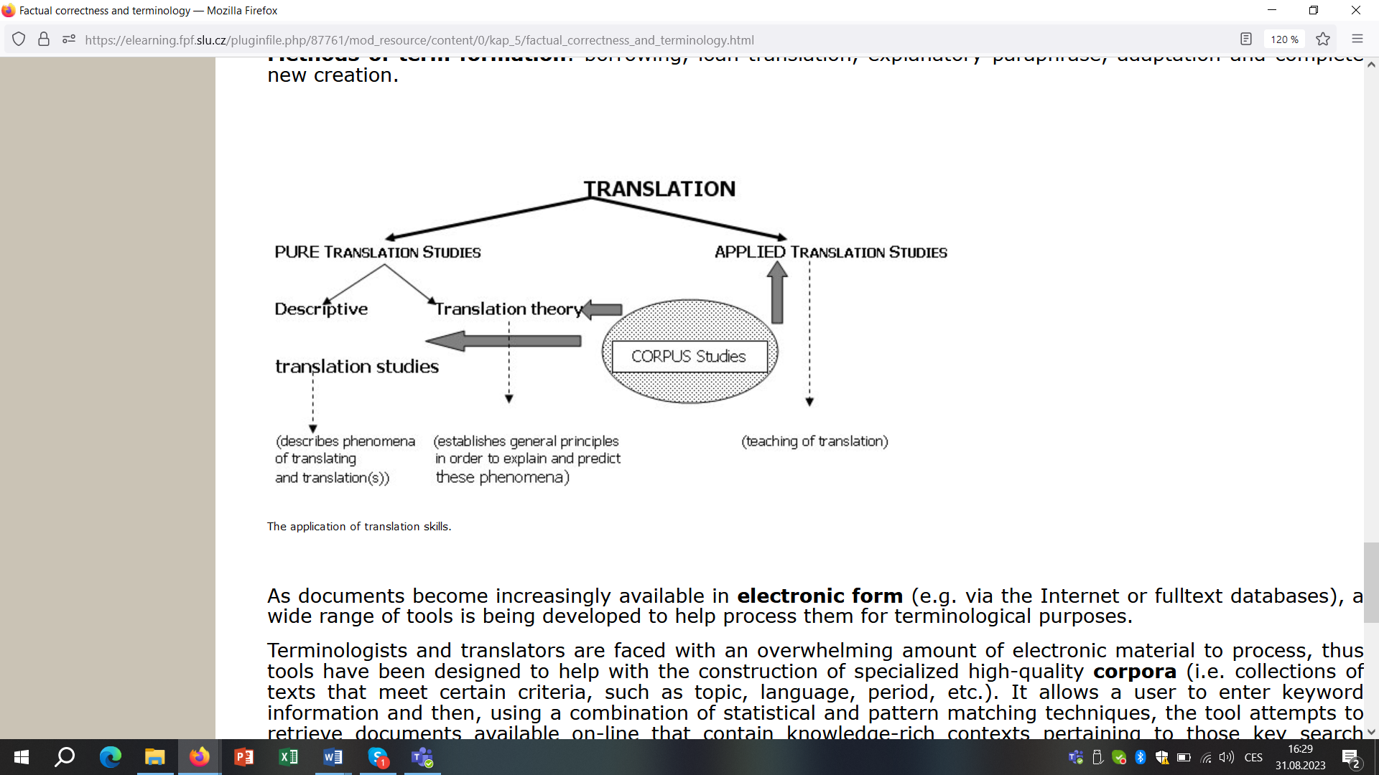
The application of translation skills.

As documents become increasingly available in electronic form (e.g. via the Internet or full text databases), a wide range of tools is being developed to help process them for terminological purposes.
Terminologists and translators are faced with an overwhelming amount of electronic material to process, thus tools have been designed to help with the construction of specialized high-quality corpora (i.e. collections of texts that meet certain criteria, such as topic, language, period, etc.). It allows a user to enter keyword information and then, using a combination of statistical and pattern matching techniques, the tool attempts to retrieve documents available on-line that contain knowledge-rich contexts pertaining to those key search terms.
Once the terminological research is complete, the next step is to present the information in a form in which it can be stored and disseminated to users. It is still possible to prepare printed glossaries or lexicons; however, such information is provided in electronic form, in term banks or term bases.
Term banks are large scale collections of electronic term records, which are entries that contain information about terms and the concepts they represent (e.g. definitions, contexts, foreign language equivalents, grammatical and usage information, conceptual relations).
However, clients may have terminological preferences that are not reflected in the term banks maintained by other institutions. Therefore, most translators find that it is also necessary to compile their own collection of term records in order to ensure that the appropriate subject fields and client preferences are adequately represented.
(Baker, Mona, Gabriela Saldanha, Eds. Routledge Encyclopaedia of Translation Studies. Abingdon: Routledge, 1998.)
TASK 3: Read the English text and then fill in the gaps in the Czech translation:
The result of the test is expressed in an average value of the measured strength always in Newton units (N). In case tablets are oriented in a certain way, the manner of their orientation shall always be specified. In case the value is unsatisfactory (outside the specification limit), the test shall be repeated with the sample of 20 tablets. The values may be under the lower specification limit only at 2 tablets of the total 30 tested tablets. The result of the test is expressed in whole valid numbers.

Výsledek se vyjadřuje v průměrné naměřené síly vždy v newton (N). V případě, že tablety byly nějakým způsobem , uvede se vždy i jejich orientace. V případě, že je nevyhovující (mimo limit specifikace), zkouška se opakuje se 20-ti tablet. Z celkového počtu 30-ti testovaných tablet mohou být u max. 2 tablet pod spodní limit . Výsledek zkoušky se uvádí v platných číslech.

Glossary of terms
Corpus (korpus) - collection of texts that meet certain criteria, such as topic, language, period, etc.
Proofreading (korektura) - final reading of the text to check grammar, spelling, punctuation.
Term banks (sbírka termínů) - are large scale collections of electronic term records, which are entries that contain information about terms and the concepts they represent.
Terminography (tvorba terminologie) refers to the group of practices concerned with the collection, description, processing and presentation of concepts and terms in a specialized field.
Terminology (odborná terminologie) - specialized vocabulary relating to a specific field of translation.

Points to remember
Methods of term formation: borrowing, loan translation, explanatory paraphrase, adaptation and complete new creation.
Proofreading is the final stage of the editing process, which focuses on surface errors such as misspellings and mistakes in grammar and punctuation. Do not rely on spell and grammar check, use dictionaries as well.
Proofreading techniques: proofread for only one kind of error at a time, read slowly, and read every word.
Term banks are large scale collections of electronic term records, which are entries that contain information about terms and the concepts they represent.
Terminology is concerned with the naming of concepts in specialized fields of knowledge, e.g. medicine, law, business, chemistry.
Notions of terminology: concept, definition and term.

