## PROSE: STORY - PLOT

**Theme** is the essential idea. A theme of the fairy tale “Little Red Riding Hood” is “Don't talk to strangers.”

A **motif** is a powerful and recognizable idea that is repeated. Can be used by various authors in different eras. Example: A comparison of seasons of the year to human life (childhood-spring, old age- autumn).

**Plot**

Structure of the Plot:

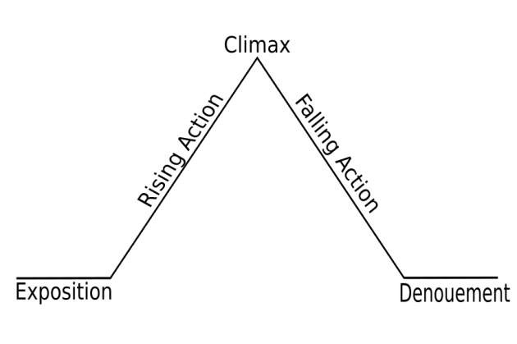

I.  **Introduction**

A. Setting: Where and when the story takes place.

B. Protagonist: The main character of the story; who the story is about.

C. Mood: How the reader feels about the story, setting and character.

D. Tone: The feelings and state of mind of the speaker or narrator.

II. **Rising Action:** the point where the protagonist meets the antagonist.

A. Conflict: 1. Person vs. Person (External Conflict)

2. Person vs. Nature (External Conflict)

3. Person vs. Himself / Herself (Internal Conflict)

4. Person vs. Society (External Conflict)

5. Person vs. Fate/ Destiny/God (External Conflict)

B. Antagonist: The character which opposes the protagonist.

III. **Climax**: The turning point.

IV. **Falling action**: Prepares reader for the end, all mysteries and secrets are uncovered.

V. **Denouement**: This is French for “unknotting” and is essentially the wrapping up of all the loose details of the plot in order to satisfy the reader or audience.

## SETTING AND CHARACTERS

**Setting** refers to the set of locations where the story takes place, real or imaginary.

**Literary space** is the environment in which characters move or live.

**Characters** are distinctive personalities who are involved in the events described by the story. They are major (primary) or minor (secondary) characters.

The process of creating a character is called **characterization**: major characters possess a memorable and complex personality, minor characters are usually the so called stock characters, i.e., stereotypical simplifications of human personalities:

* **Main characters:**

1. Antagonist – a hero/heroine who actively opposes the protagonist, very often depicted as evil.
2. Anti-hero – a protagonist who expresses traits of an antagonist, but in the end he/she is revealed as the good one.
3. Evil twin – an antagonist who is identical to the protagonist, but stands on the opposing side.
4. False protagonist – a character who is introduced as a protagonist at the beginning of the story, but usually killed shortly after.
5. Protagonist – a hero/heroine of the story.
6. Tragic hero – a character whose personality has some tragic flaw that causes him/her constant suffering.
7. Villain – the most stereotypical type of an antagonist, depicted as an utterly evil person hating everyone and everything, with a strong urge to destroy.

* **Stock characters:**

A stock character is a character that relies heavily on stereotypes and is widely recognizable: absent-minded professor,

bad fiancé,

damsel in distress,

dumb blonde,

dark lord,

evil genius,

femme fatale,

mad scientist,

private investigator.