1 Pronounce the following groups of words (according to RP – look them up at oald online) and write down their transcription. Comment on the quality and quantity of these short/long vowels.

had – hat beat – bid nought – nod

2 Transcribe the following words and pronounce them correctly:

bit – lip beat – leap happy – early he – we

3 Transcribe the following groups of words. Pronounce them correctly and distinguish the quality of their long vowels, diphthongs and short vowels.

fee – feed – feet bye – bide – bite said – set

4 On the vowel diagram provided, indicate the glides for the diphthongs in the following words:

a) fight

b) home

c) clear

d) cow

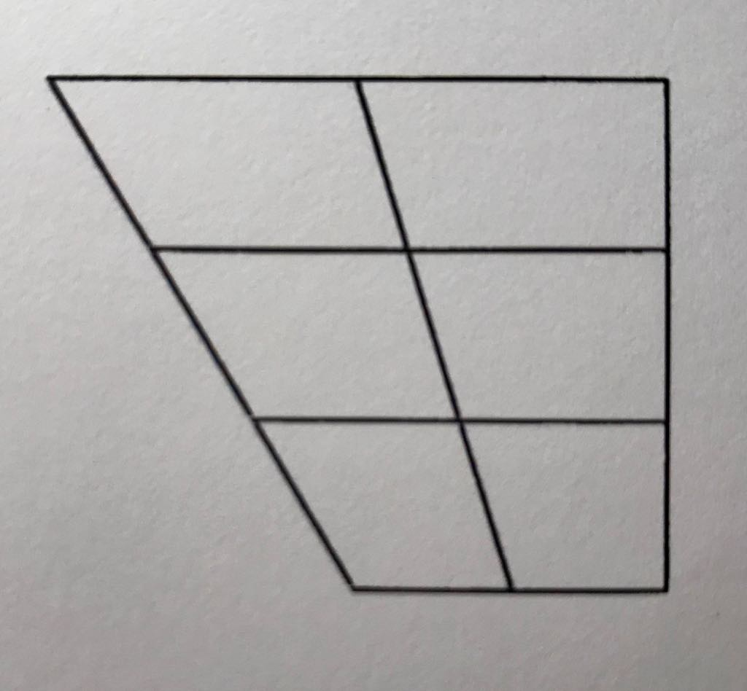

5 Write the symbols for the long vowels in the following words:

a) broad

b) ward

c) calf

d) learn

e) cool

f) team

g) err

h) seal

i) curl

6 Write the symbols for the diphthongs in the following words:

a) tone

b) style

c) out

d) way

e) beer

f) coil

g) hair

h) why

i) prey

7 Write the names in the chart.

Ad**e**le, **A**lex, B**i**ll, Chr**i**s, **E**mily, **E**ve, J**a**mes, J**o**e, K**a**te, L**e**o, M**i**ke, P**au**la, R**y**an, S**a**m, S**ea**n, S**o**phie

|  |  |  |  |
| --- | --- | --- | --- |
| æ  __________  __________ | eɪ  __________  __________ | e  _e.g. *Ad****e****l*__  __________ | i:  __________  __________ |
| ɪ  __________  __________ | aɪ  __________  __________ | ɔ:  __________  __________ | əʊ  __________  __________ |