## AUTHOR AND AUDIENCE

An **author** is the person who creates a written work (a book, an article, a poem, a technical text). One of the key issues of literary theory is the relationship between the meaning of a literary text and its author´s intent.

* **Narrative communication:**

1. Level of nonfictional communication – author – reader.
2. Level of fictional mediation – narrator – addressee(s).
3. Level of action – character – character.

**Authorial audience:** The audience of real readers addressed by the author.

**Narrative audience:** The fictional audience addressed by the narrator.

A **person** is a real-life person, anyone occupying a place on the level of nonfictional communication

A **character** is not a real-life person but only a paper being, a being created by an author and existing only within a fictional text.

## NARRATOLOGY

The first question before analyzing the text is: “Who speaks?

“A **narrator** is the speaker who decides *what* is to be told, *how* it is to be told (perspective or a point of view, and in what order), and *what is to be left out.*”

Stanzel intended to show **how narratives** work in a typological circle:

* **mediacy**:
  + Person (first person or third person)
  + Perspective (internal or external)
  + Mode (narrator or reflector)
* **Narrative situations**:
  + First-Person narrative situation (1st person narrator)
  + Authorial narrative situation (omniscient narrator)
  + Figural narrative situation (Reflector)

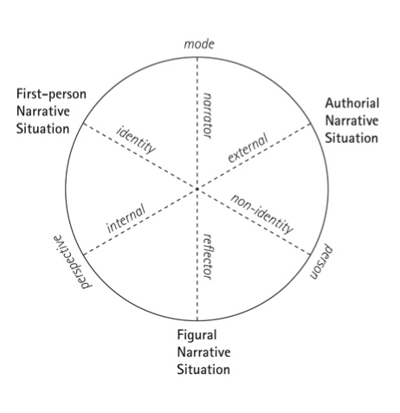

**1st person narrator**

* narrator who is present as a character in his/her story
* events s/he has experienced himself
* narrator (**narrating I**) is also a character (**experiencing I**)

**Unreliable Narrator:** A narrator "whose rendering of the story and/or commentary on it the reader has reasons to suspect. [...] The main sources of unreliability are the narrator's limited knowledge, his personal involvement, and his problematic value-scheme."

* I-as-protagonist / I-as-witness (*Moll Flanders*/ Nick *The Great Gatsby*)

**Example:**

In my younger and more vulnerable years my father gave me some advice that I’ve been turning over in my mind ever since. “Whenever you feel like criticizing any one,” he told me, “just remember that all the people in this world haven’t had the advantages that you’ve had.” He didn’t say any more, but we’ve always been unusually communicative in a reserved way, and I understood that he meant a great deal more than that. In consequence, I’m inclined to reserve all judgments, a habit that has opened up many curious natures to me and also made me the victim of not a few veteran bores. (*The Great Gatsby*, opening paragraph).

**Authorial Narrator**

* no character in the story itself (impersonal narration)
* status of an outsider => godlike abilities such as omniscience and omnipresence
* may speak directly to their addressees, in order to comment on action and characters and to engage in philosophical reflection or socio-political criticism and the like
* Reliable Narrator: A narrator "whose rendering of the story and commentary on it the reader is supposed to take as an authoritative account of the fictional truth."

**Example:**

The twin city of proud Ankh and pestilent Morpork, of which all the other cities of time and space are, as it were, mere reflections, has stood many assualts in its long and crowded history and has always risen to flourish again. So the fire and its subsequent flood, which destroyed everything left that was not flammable and added a particularly noisome flux to the survivors’ problems, did not mark its end. Rather it was a fiery punctuation mark, a coal-like comma, or salamander semicolon, in a continuing story.’ (Terry Pratchett, *The Colour of Magic*)

**Reflector**

* subjective reflector; internal focalizer
* effect: attract attention *to* the mind of the reflector-character
* through the eyes of a character in story => third-person, all is seen through the character’s eyes - - subjective narrative

**Example:**

what a variety of smells interwoven in subtlest combination thrilled his nostrils; strong smells of earth, sweet smells of flowers; nameless smells of leaf and bramble; sour smells as they crossed the road; pungent smells as they entered bean-fields. But suddenly down the wind came tearing a smell sharper, stronger, more lacerating than any – a smell that ripped across his brain stirring a thousand instincts, releasing a million memories – the smell of hare, the smell of fox. Off he flashed like a fish drawn in a rush through water further and further. (Virginia Woolf, *Flush).*