Basic rules of formal correspondence
In correspondence that does not have a letterhead, the sender's address is placed in the top right-hand corner of the page. It is also acceptable, but less common, to place it in the top left-hand corner. The blocked style is the most widely used, i.e. each line starts directly below the one above. In the UK it is not usual to write the sender's name before his or her address.
The date is written directly below the sender's address, separated from it by a space. In the case of correspondence with a letterhead, it is usually written on the right-hand side of the page. The month in the date should not be written in figures as this can be confusing; for example 11.3.03 means 11 March 2003 in British English, where the sequence is day-month-year, but 3 November 2003 in American English, where the sequence is month-day-year. It is acceptable to write the date with or without the abbreviations -th and -nd, e.g. 24th October or 24 October, and to transpose the date and the month, e.g. October 24 or 24 October. Whatever you choose you should be consistent throughout your correspondence.
The inside address is written below the sender's address and on the left-hand side of the page. If you know the name of the person you are writing to, write it as the first line of the address. Include either the person's initial/s or his or her first given name, e.g. Mr. J. E. Smith or Mr. John Smith.
Courtesy titles used in addresses are as follows:
— Mr is the usual courtesy title for a man. The unabbreviated form Mister should not be used.
— Mrs is used for a married woman.
— Miss is used for an unmarried woman.
— Ms is used for both married and unmarried women. It is advisable to use this form of address when you are unsure whether the woman you are writing to is married or not, or do not know which title she prefers.
If you do not know the name of the person you are writing to, but know their job title, you can use that, e.g. The Sales Manager, The Finance Director, in the inside address. Alternatively, you can address your letter to a particular department of the company, e.g. The Sales Department, The Accounts Department. Finally, if you know nothing about the company and do not know which person or department your letter should go to, you can simply address the letter to the company itself.
After the name of the person and/or company receiving the letter, the recommended order and style of addresses in the UK is as follows:
— Name of house or building (Industrial House)
— Number of building and name of street, road, avenue, etc. (34-41 Craig Road)
— Name of town or city and postcode (Bolton)
— Name of country (UK)
It is simplest to follow the above order and style, though variations are possible: for example, the name of the county, e.g. Lancashire, may, if known, be included on the line below the name of the town or city; the postcode may be written on a separate line; the name of the town, as well as the country, may be in capital letters.
An alternative to including the recipient's name or job title in the address is to use an attention line. Salutation Dear Sir opens a letter written to a man whose name you do not know. Dear Sirs is used to address a company. (In American English a letter to a company usually opens with Gentlemen.) Dear Madam is used to address a woman, whether single or married, whose name you do not know. Dear Sir or Madam (or Dear Sir / Madam) is used to address a person when you do not know their name or sex. When you know the name of the person you are writing to, but do not know them well, the salutation takes the form of Dear followed by a courtesy title and the person's surname. Initials or first names are not used with courtesy titles, e.g. Dear Mr. Smifh, not Dear Mr. J. Smith or Dear Mr. John Smith. Business associates who you know well can be addressed using just their first name, e.g. Dear John. A comma after the salutation is optional, i.e. Dear Mr. Smith, or Dear Mr. Smith. (In American English a colon is usually used after the salutation, e.g. Dear Mr. Smith:, Gentlemen:).
The blocked style is the one most often used for the body of the letter. It is usual to leave a line space between paragraphs. If the letter begins Dear Sir, Dear Sirs, Dear Madam, or Dear Sir or Madam, the complimentary close should be Yours faithfully. If the letter begins with a personal name, e.g. Dear Mr James, Dear Mrs Robinson, or Dear Ms Jasmin, it should be Yours sincerely. A letter to someone you know well may close with the more informal Best wishes. Note that Americans tend to close even formal letters with Yours truly or Truly yours, which is unusual in the UK in commercial correspondence. Avoid closing with old-fashioned phrases, e.g. We remain yours faithfully, Respectfully yours. A comma after the complimentary close is optional, i.e. Yours faithfully, or Yours faithfully. The complimentary close is usually placed on the left, aligned under the rest of the letter.
Always type your name and, if relevant, your job title, below your handwritten signature. This is known as the signature block. Even though you may think your handwriting is easy to read, letters such as a, e, o, r, and v can easily be confused. It is, to some extent, a matter of choice whether you sign with your initial/s, e.g. D. Jenkins, or your full given name, e.g. David Jenkins, and whether you include your courtesy title in your signature block. But if you include neither your given name nor your title, your correspondent will not be able to identify your sex and may give you the wrong title when he or she replies.
The abbreviation p.p. sometimes appears in signature blocks. It means per pro, i.e. for and on behalf of, and is used by administrators or personal assistants when signing letters on behalf of their managers. When sending a letter or email on behalf of your company, it is a good idea to include your job title in the signature block, especially if your recipient has not dealt with you before.
If there are any documents enclosed with a letter, although these may be mentioned in the body of the letter, it is also common to write Enc. or Encl. below the signature block. If there are a number of documents, these can be listed, e.g.:
Enc.
Bill of lading (3 copies)
Insurance certificate (1 copy)
Certificate of origin (1 copy)
Bill of exchange (1 copy)
Private and confidential may be written at the head of a letter and on the envelope, in cases where the letter is intended to be read only by the addressee. There are many variations of this phrase, e.g. Confidential, Strictly confidential.
A subject title at the beginning of a letter, directly after the salutation, provides a further reference, saves introducing the subject in the first paragraph, immediately draws attention to the topic of the letter, and allows the writer to refer to it throughout.
It is not necessary to begin the subject title with Re. (with regard to), e.g. Re.: Application for the post of web designer. When sending email messages this may even be confusing as RE is short for reply.
When copies are sent to people other than the named recipient, c.c. (carbon copy) is added, usually at the end of a letter, before the name/s of the recipient/s of the copies. Sometimes you will not want the named recipient to know that other people have received copies. In this case, b.c.c (blind carbon copy), and the name/s of the recipient/s, are added on the copies themselves, though not, of course, on the top copy. These abbreviations are used in email, and mean exactly the same thing.

Examples:

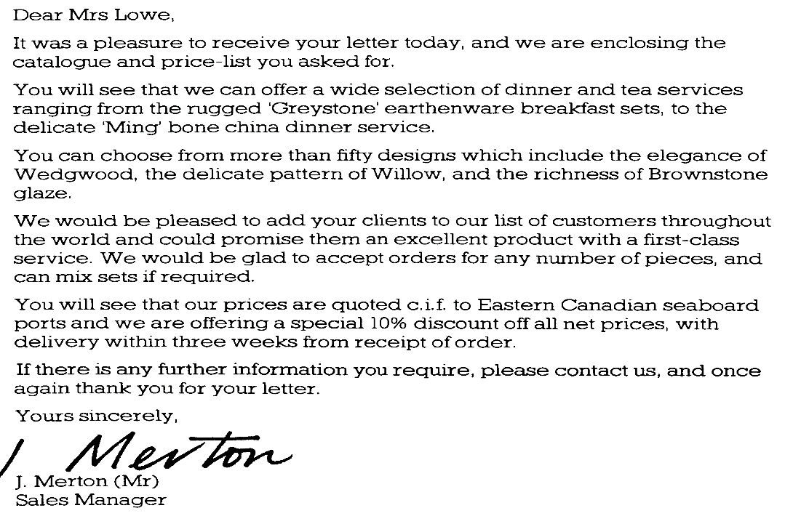

Use Dear with the person’s title and surname when you are contacting the person for the first time and you have a formal relationship. The word colleague is used when writing to an identifiable group in more formal correspondence, you can use singular or plural. Full verb forms are often used in formal communications (I am writing …). Best regards can be used in formal instead of Yours faithfully/sincerely.

- E-mail:
From: Customer Service <customer.service@johnston-technology.com>
Sent: Tuesday 2 April 09:33:25
To: “O. Poujade” <oliver.poujade@hmail.com>
Re: Your service request

Dear Mr Poujade,
Thank you for your email concerning your memory module. We are sorry that you are not satisfied with this product; we will be pleased to exchange it under the terms of our guarantee.Please do not return the module until you have received an RMA (return merchandise authorization). To issue the RMA we require the revision number of the module (the long alphanumeric number, beginning with 00) and your delivery address, telephone number and your email address.
You will then receive an email, containing details of where to send your original product, together with your RMA number and the name and email address of the RMA department representative handling your case.
A printed copy of the email should be returned to the RMA department together with the faulty module. Your request will normally be processed within two working days and your replacement module shipped within a week.
Yours sincerely,
Karen Smith,
Customer Service Executive

- Formal letters:

Dear Mr Black,
I am writing to remind you that your account with us is currently overdue. Please find enclosed astatement of your account, which shows a balance due of £1,750.
If there is some reason why you have not been able to send your payment, please call us to discuss the problem. If it would be more convenient, please feel free to reply by email to h.koch@voronox.com.
Thank you for your prompt attention to this matter.
Yours sincerely,
Hannah Koch
Sales Manager

Dear Ms Koch,
Your letter arrived while my assistant was on holiday and I am afraid your invoice was mislaid. I enclose a cheque for £1,750 – please accept my sincere apologies for any inconvenience caused.
Our customers are very pleased with your spare parts, and I look forward to placing another order with you in the near future.
Sincerely,
Gilroy Black

Useful phrases
I look forward to hearing from you.
I look forward to meeting/ seeing you.
If you have any queries, please call me.
If you have any questions, please call me.
Many thanks for helping out with the conference.
Many thanks for the invitation.
It was very kind of you to invite me.
We really appreciate all your help.
We are very grateful for your help.
We are sorry to inform you that Mr. Smith has left the company.
Unfortunately, I am going to miss the presentation.
I hope I will be able to come next time.
Do you have any suggestions?
This is to inform you that the package will be late.
Email – receive/send/reply to/forward, attach a document/picture
Thanks for your email …
Please find attached …
Please let me know if you cannot read the attachment.
Do forward it to the manager.
Please reply asap (as soon as possible).

