1. den
https://mapy.com/cs/zakladni?planovani-trasy&rc=9ppCKxWWT.9ovqFxXDuA9c.IIxXT-h&rs=pubt&rs=traf&rs=area&ri=15212380&ri=54783&ri=30752&mrp=%7B%22c%22%3A111%2C%22dt%22%3A%22%22%2C%22d%22%3Atrue%7D&xc=%5B%5D&rut=1&x=15.4280528&y=49.5895264&z=8
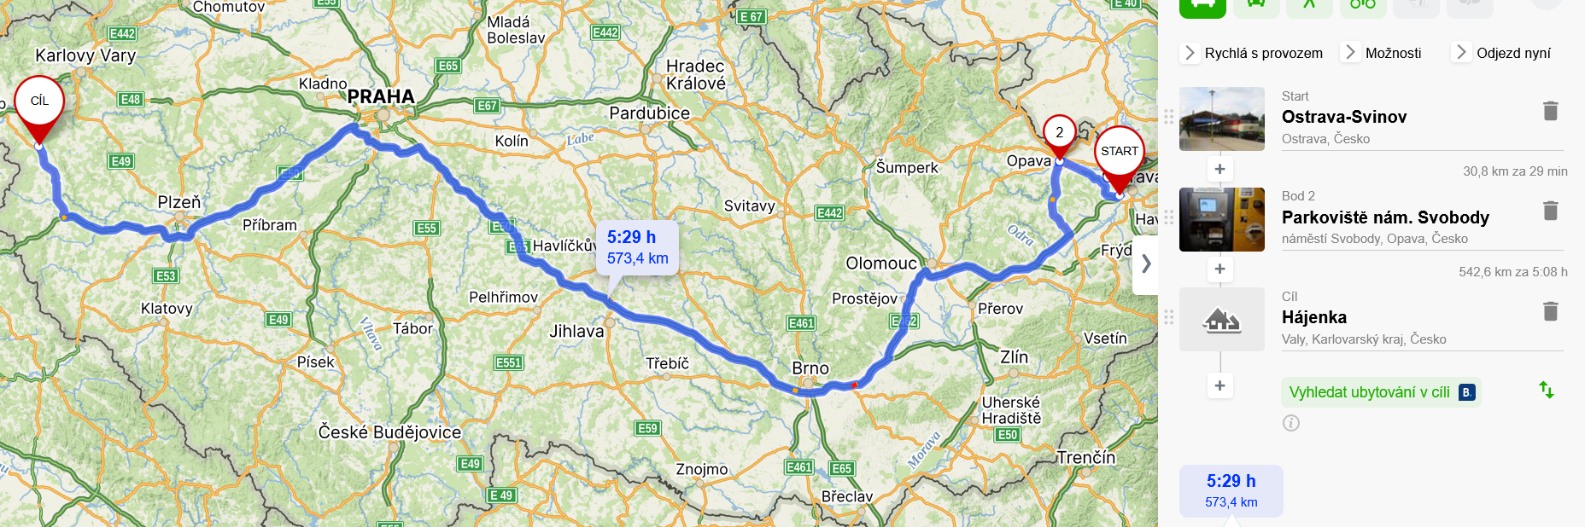

2. den
https://mapy.com/cs/zakladni?planovani-trasy&rc=9c.IIxXT-h9daXKxXw5GjsWxYnL69c.IIxXT-h&rs=area&rs=firm&rs=muni&rs=area&ri=30752&ri=12846717&ri=1253&ri=30752&mrp=%7B%22c%22%3A111%2C%22dt%22%3A%22%22%2C%22d%22%3Atrue%7D&xc=%5B%5D&rut=1&x=12.7634438&y=50.1258860&z=11
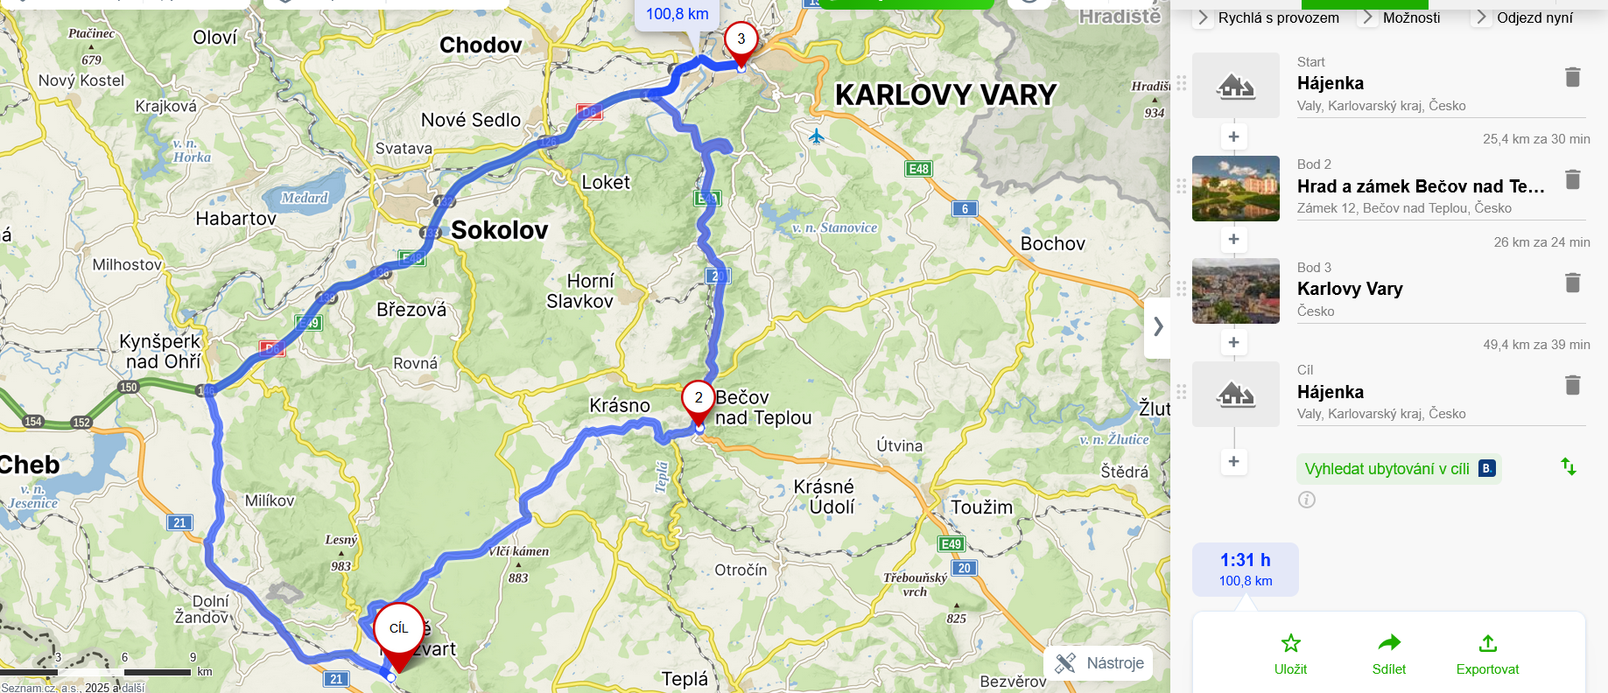

3. den
https://mapy.com/cs/zakladni?planovani-trasy&rc=9c.IIxXT-h9dmWUxUq1ejh.d3VdPvdui9dAxOxVfq83LuxXT-h&rs=area&rs=base&rs=firm&rs=base&rs=firm&rs=area&ri=30752&ri=1833208&ri=2432592&ri=1891580&ri=12921969&ri=30752&mrp=%7B%22c%22%3A111%2C%22dt%22%3A%22%22%2C%22d%22%3Atrue%7D&xc=%5B%5D&rut=1&x=13.0510169&y=49.7947413&z=10
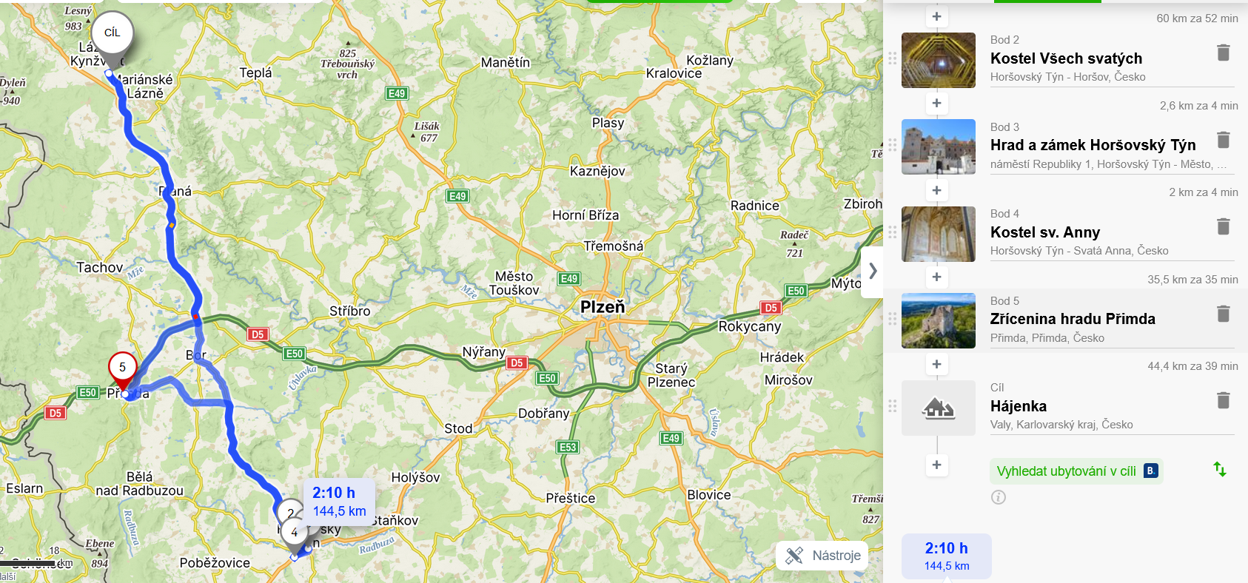

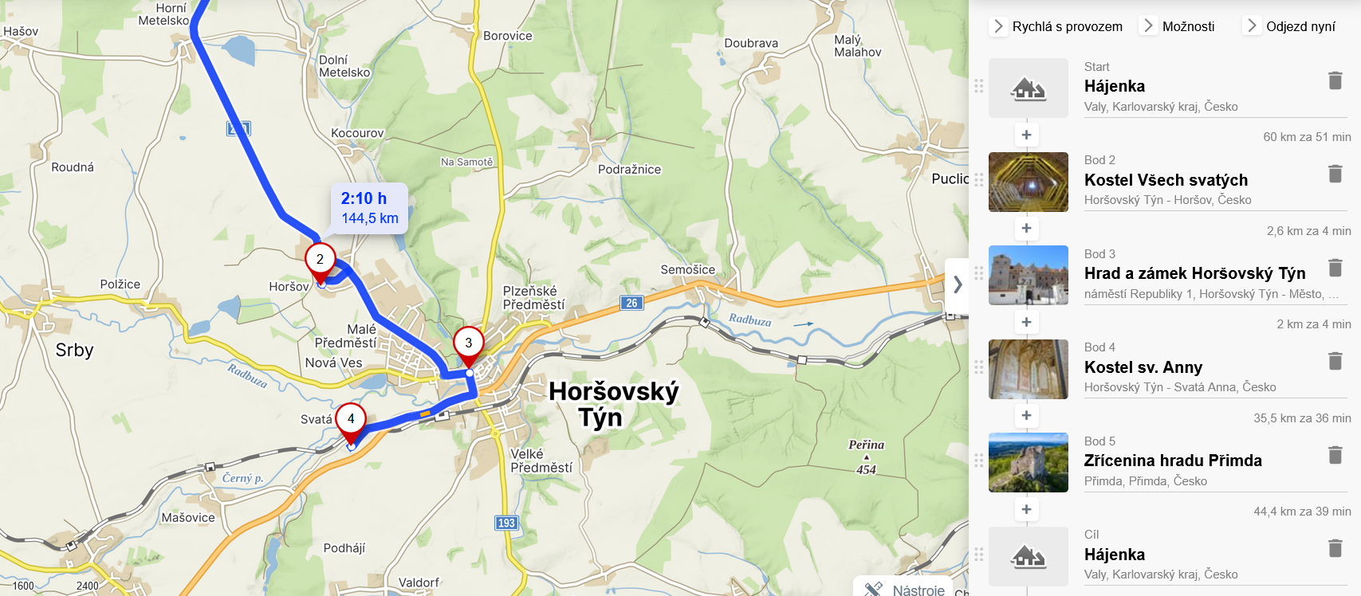

4. den
https://mapy.com/cs/zakladni?planovani-trasy&rc=9c.IIxXT-h9e23vxXDg79c.IIxXT-h&rs=area&rs=base&rs=area&ri=30752&ri=1863925&ri=30752&mrp=%7B%22c%22%3A111%2C%22dt%22%3A%22%22%2C%22d%22%3Atrue%7D&xc=%5B%5D&rut=1&x=13.0810046&y=50.0080416&z=10
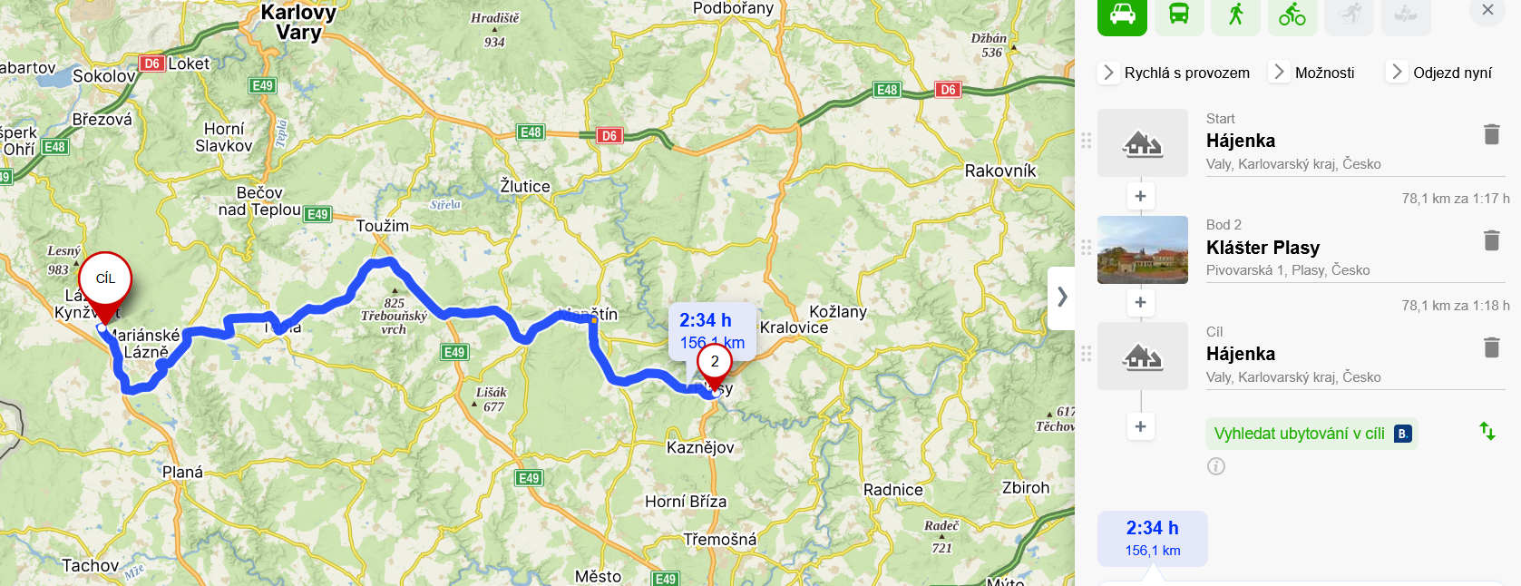
MANĚTÍN

5. den
https://mapy.com/cs/zakladni?planovani-trasy&rc=9c.IIxXT-h9dyioxVphD9fZi1xU4629ow21xXEN-&rs=area&rs=firm&rs=firm&rs=muni&ri=30752&ri=2432600&ri=13574379&ri=4660&mrp=%7B%22c%22%3A111%2C%22dt%22%3A%22%22%2C%22d%22%3Atrue%7D&xc=%5B%5D&rut=1&x=15.3028594&y=49.5563418&z=8
