The Circulatory System
The circulatory system consists of the heart and the vascular system, so it is often called the cardiovascular system. Normal cellular activity is dependent upon a constant supply of oxygen, nutrients and certain chemicals, as well as the removal of metabolic waste products. This transportation of materials to and from tissue cells by the propulsion of blood through a closed system of tubes is called the circulation.
The Heart
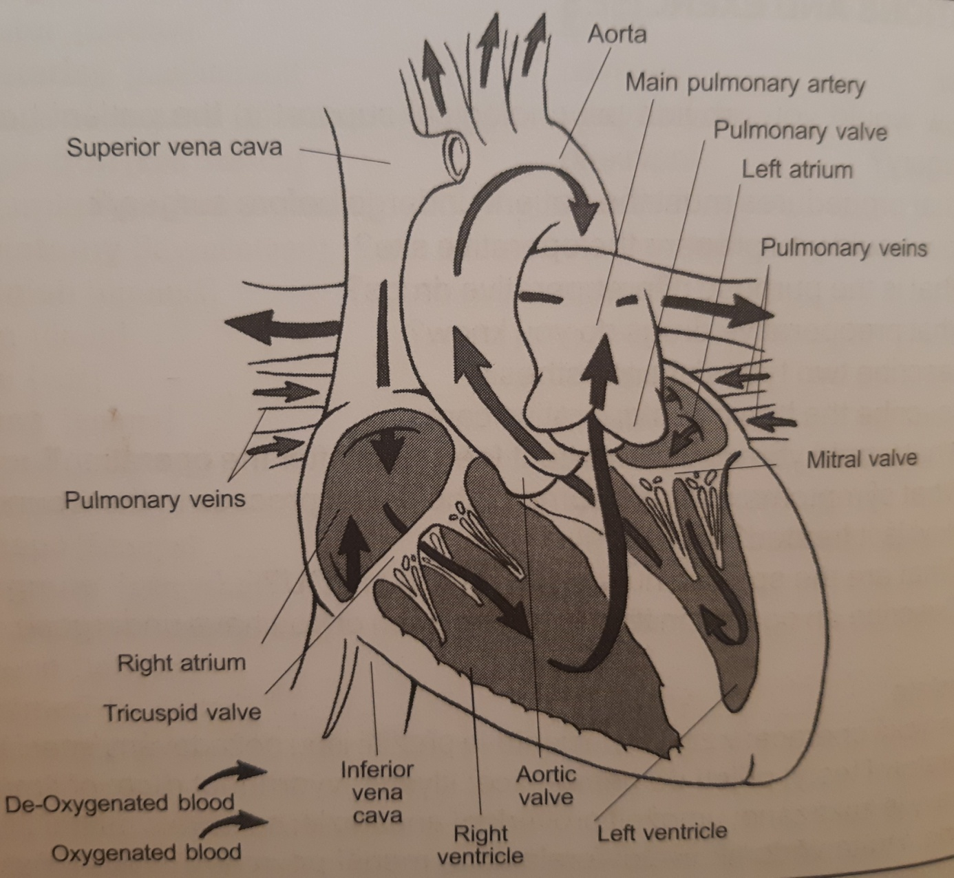
The heart is a hollow muscular organ situated in the mediastinum. It is generally orientated tilting slightly to the left. It has an apex and a base. The heart receives its blood supply via the coronary arteries and is drained by veins, which include the coronary sinus. It is divided into four chambers, two on the right and two on the left side. The upper chambers are called the atria, the two larger lower ones are called the ventricles. All chambers of the heart have valves that keep the blood flowing in the right direction.
Normally there is no contact between the right and the left sides, which are separated by the septum.
The space between heart layers provides room for the heart to expand and contract with each heartbeat. The contraction phase is termed systole, the relaxation phase is termed diastole.
Vascular System
The blood is carried throughout the body within the vessels. There are three types of blood vessels, each with specific functions:
- Arteries, which transport blood away from the heart. They vary in size, the aorta is the largest in the body and arterioles (small branches of the arteries) are the smallest.
- Capillaries, which receive blood from the arterioles. Nutrients in the blood pass through capillary walls to blood cells, and waste products from body cells into the blood, to be transported to other parts of the body for the elimination. Blood then flows from capillaries into small veins.
- Veins carry blood back to the heart. The smallest veins are called venules, the largest vein is the vena cava, which carries blood to the right atrium.

Function of the Heart
The oxygenated blood leaves the lungs and enters the left atrium of the heart through the pulmonary veins, passing through the mitral valve into the left ventricle, from where it is pumped via the aorta around the body, returning to the right atrium of the heart being depleted in oxygen, through the superior and inferior vena cava. From the right atrium the blood passes through the tricuspid valve into the right ventricle, from where it is pumped into the lungs via the pulmonary artery, picking up oxygen and releasing carbon dioxide before returning to the left atrium through the pulmonary veins.
The amount of blood pumped out by each ventricle every minute is about 5 liters, this is termed the cardiac output. The total amount of blood circulates the body once every minute. The heartbeat is approximately 70 beats a minute and this is termed the heart rate. It is the heart rate that the nurse measures when she takes a pulse. Changes in the pulse rate are normal during daily activity and are affected especially by exercise, eating, strong emotions, bodybuilding, age, sex and illness. Examples of conditions that cause a faster pulse rate are elevated body temperature, certain cases of heart disease, shock and haemorrhage.
An extremely fast pulse is called tachycardia and an abnormally slow pulse rate is bradycardia; a pulse rate less than 50 and also above 100 can be serious and should be reported. The arterial pulse may be located anywhere in the body where an artery lies between the skin and a bone.
The usual site for recording a blood pressure is the left arm. The patient is placed in a comfortable position and an inflatable cuff is placed on the upper arm. The cuff is attached to the sphygmomanometer and the nurse locates the brachial pulse. Then she locates the radial pulse with one hand and maintains this location while inflating the cuff with the other hand. The stethoscope is now placed over the brachial artery and the valve is used to slowly deflate the cuff. As the column of mercury falls, a sound is heard and the point at which this is heard is noted - the systolic pressure. As the mercury continues to fall, the sound becomes louder until suddenly the quality of the sound changes and becomes muffled, this point is termed as the diastolic pressure, and the sound then disappears.
Electrocardiography is the study of electrical activity associated with heart contractions. The Electrocardiogram (ECG), which produces a visible record of heart activity, provides one of the most dependable aids in assessing heart function and in diagnosing heart disease.
The heart diseases may be classified of follows:
1. Congenital cardiovascular defects-such as ventricular septal defects and others.
2. Inflammatory diseases, which may result in structural changes within the heart, such as rheumatic fever, bacterial endocarditis and pericarditis.
3. Deficiency in the blood supply to the myocardium, as coronary arteriosclerosis, angina pectoris and myocardial infarction.
4. Disturbances in conduction, e.g. arrhythmias, tachycarditis, bradycarditis and others.
5. Decompensation, or heart failure, which is a term used to describe the condition when the ventricles of the heart are not pumping sufficient blood around the body for its needs. It may involve the left ventricle only or both ventricles.
Angina pectoris is a serious disease when the coronary arteries may be narrowed by atheroma. This narrowing may at times cause ischaemia of the myocardium giving rise to the disease. The plaques of atheroma offers resistance to the blood as it passes through the coronary arteries and the likelihood of a clot developing is increased, giving rise to coronary thrombosis. A thrombus in the coronary artery may lead to occlusion and deprive an area of the myocardium of its blood supply, causing death of the myocardium, the so-called myocardial infarction.
Deep vein thrombosis is a condition that can occur as a complication of bed rest of following surgery. A part of the clot may break off and travel to the lungs and cause pulmonary embolism.
This very common disease at present is connected with the patient’s blood pressure and Is known as hypertension. It is a condition in which there is a sustained elevation of the arterial blood pressure (which is mostly considered to be between 140/80 and 160/90 mmHg) that may cause the heart failure or vascular haemorrhage.

