THE NERVOUS SYSTEM
The nervous system is an integrated multipurpose system made up of many parts. It contains the higher human functions such as memory and reasoning, controls and coordinates all parts of the body and provides a complex communication system between the body’s internal and external environments.
Structurally, the nervous system is composed of two main parts:
1. The central nervous system (CNS), which consists of the brain and spinal cord.
2. The peripheral nervous system, e.g. spinal and cranial nerves.
There are also two functional divisions of the nervous system as:
a) The somatic or voluntary nervous system, which is concerned with the transmission of impulses (coded messages) to and from the nonvisceral parts of the body such as skeletal muscles, bones, joints, ligaments, skin, eyes and ears.
b) The autonomic or involuntary nervous system, which is concerned with regulation of the activities of visceral muscles and glands.
THE BRAIN
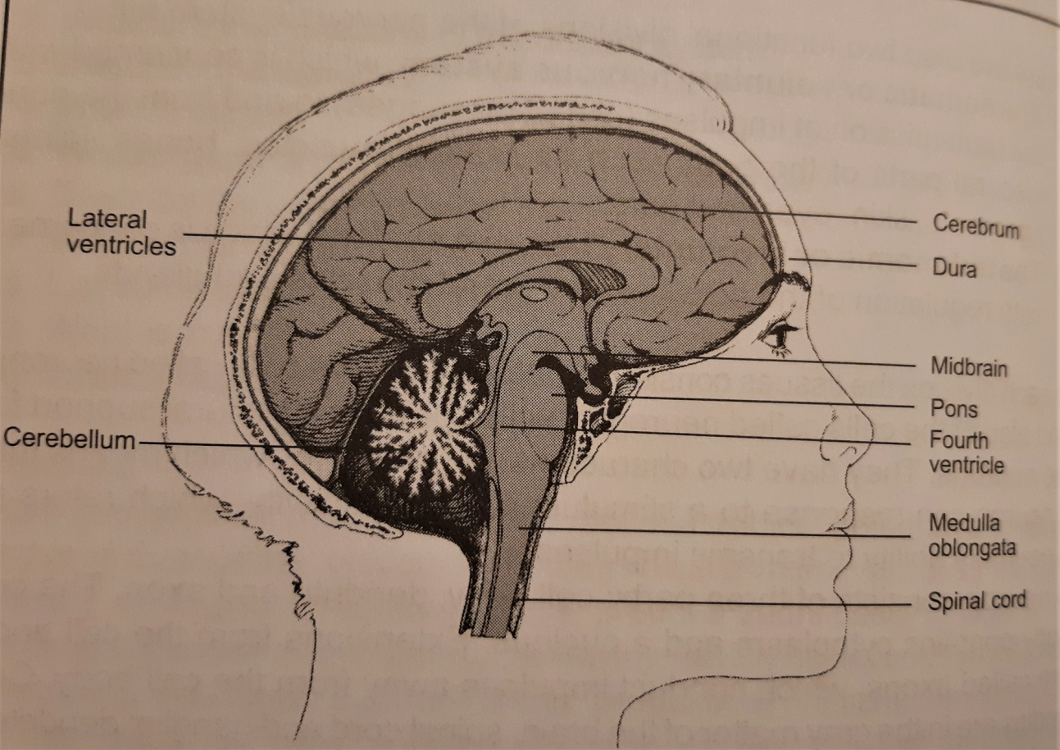

Disorders of the Nervous System
They are very serious and life threatening and most of them leave the patient with a disability. The discipline dealing with the neural problems is known as neurology.
The most common disorders known are speech dysfunctions such as aphasia (loss of ability to understand words or to use them to communicate), dysphasia (lack of ability to put the words in order), dyslexia (inability to comprehend written words), etc.
Parkinson’s disease, which is shown by abnormal motor activities, tremors, rigidity, slowness and limited voluntary movements that may occur due to the blockage of dopamine secretion (it is an amino acid needed for transmission of nerve impulses in the basal ganglia). There is no cure for any form of this disease.
Mental changes include disorientation to time or place and confusion.
Causes of delirium include dysfunction of the cerebral cortex, withdrawal of alcohol or drugs and high body temperature (usually over 40.5). If it is difficult to arouse a patient, the level of consciousness is called stupor; a state of unconsciousness from which the patient usually cannot be aroused is called a coma.
Multiple sclerosis is a condition in which the myelin sheath of nerves is destroyed and white matter in the brain and spinal cord is affected. As the disease progresses, mental changes occur and the patient may need custodial care. Viruses or bacteria may also cause some of the disorders, for instance: meningitis, encephalitis or poliomyelitis. All of them are manifested by high body temperature, severe headache, nausea, vomiting and lethargy.
Meningitis is an infection of the meninges caused by streptococci, pneumococci or staphylococci that travel to meninges via the bloodstream from another part of the body, such as nose, throat or middle ear. Antibiotic therapy is the primary treatment. A complication of an infection elsewhere in the body, especially influenza, chicken pox or measles, is encephalitis (known as sleeping sickness). There is no drug that destroys the virus, so treatment is directed towards relief of symptoms.
Poliomyelitis is a viral infection of motor neurons in the spinal cord and brain stem, caused by three strains of viruses. It does not respond to drug therapy, but inoculation with vaccine is effective for all three strains.
An electro-encephalogram (EEG) is a recording of electrical activity in the brain; electrodes are placed on the patient’s head and cell activity (known as brain waves) is recorded on a graph. An ultrasound study of the brain is called an echoencephalogram.

