THE RESPIRATORY SYSTEM
The respiratory system is associated with the exchange of gases between man and his environment and also between the tissue cells and the blood. All body cells need a continuous supply of oxygen and also need to be able to get rid of carbon dioxide, which is produced by cell metabolism. Those functions are achieved by ventilation that involves the passage of air from the atmosphere to the alveoli and from the alveoli back to the atmosphere. This consists of two acts:
a) Inspiration - or taking air into the lungs because of the negative interpleural pressure created by enlarging of the thoracic cavity,
b) Expiration - or exhaling air out of the lungs during which the muscles of respiration return to their former position.
The movement of gases from a region of high tension to a region of low tension takes place through the capillary/alveolar membrane. 1 his process is termed diffusion. When blood passes through the lung capillaries, the tension of oxygen in the alveoli is higher than that of the blood and it passes through the membrane to a region of lower tension. Respiration consists of two phases: external and internal.
External respiration involves the exchange of oxygen and carbon dioxide in the capillaries and alveoli of the lungs.
Internal respiration is the exchange of oxygen and carbon dioxide between cells and capillaries through the body.
The structures concerned with ventilation are the upper and lower respiratory tracts, respiratory muscles, thorax and portions of the nervous system.
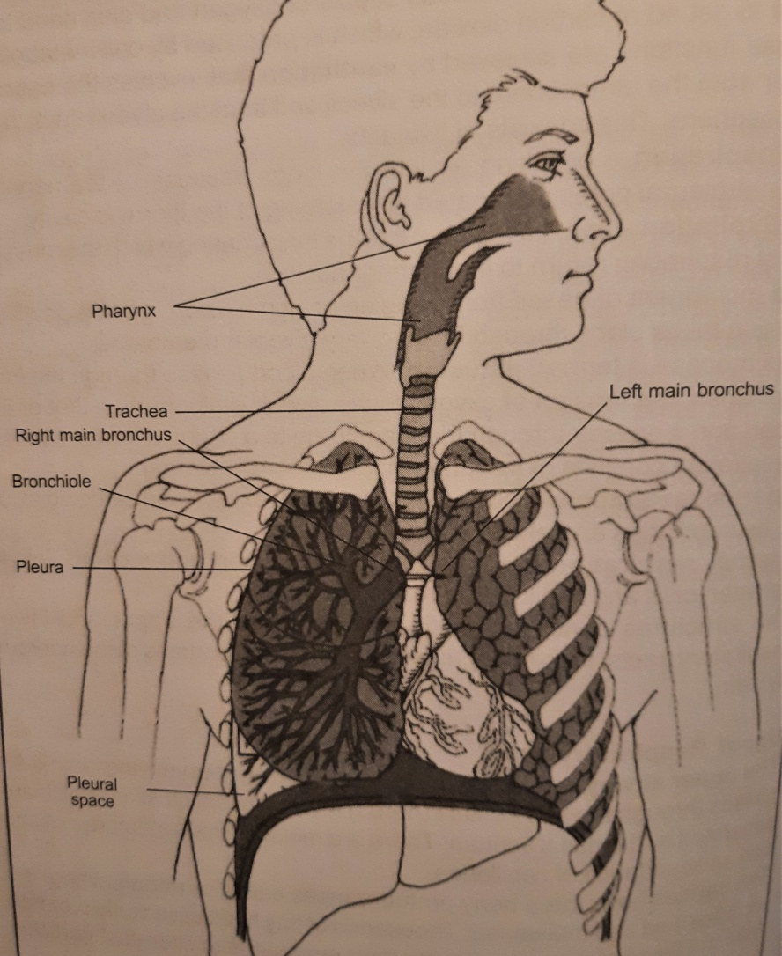 THE RESPIRATORY TRACT
Upper Respiratory Tract
The upper airway is formed by the nose, mouth, pharynx and larynx. Air passes through the two nostrils (nares) into the nasal cavities, which are separated by the nasal septum. There is a moist mucous membrane lining and an abundance of capillaries. Several small cavities known as sinuses are located in the skull near the nasal cavities: ethmoidal sinus, sphenoidal sinus, maxillary sinus and frontal sinus. Each connects with the nasal cavities by a narrow passageway. These airspaces serve as resonating chambers and their size and shape affects the quality of the voice. From the nasal cavities the air passes into the pharynx, or throat, which is separated into three portions: a) Nasopharynx - portion behind the nasal cavities, b) Oropharynx - portion behind the mouth, c) Laryngopharynx - lower section that joins the larynx. The adenoids are located in the nasopharynx and the tonsils in the oropharynx. These two pairs of lymphoid tissue protect the body against Infection by trapping bacteria that enter the nose and throat.
The larynx is a tube-like structure made up of muscles and a series of cartilage rings that can be felt through the skin over the throat; the largest ring is called Adam’s apple. It contains the vocal cords, which are responsible for the sound production, and is continuous with the trachea below.
Lower Respiratory Tract
The lower tract consists of the trachea, bronchi and two lungs.
The trachea enters the chest cavity and connects with the bronchi. Its function is to provide a passage for air to reach the lungs.
The bronchi and lung are situated in the thoracic cavity, which is lined with a moist memebrane called the pleura. The trachea branches as it enters the thoracic cavity to form the left bronchus and the principal bronchus, which is shorter and more vertical. Each bronchus enters a lung where it branches like a tree to form many smaller tubes called bronchioles. At the end of each bronchiole there is a microscopic alveolus, or air sac.
The lungs are two large organs covered with visceral pleura and are separated by the mediastinum, which contains the heart and great vessels, the oesophagus, trachea, bronchi and lymphatic ducts and nodes. The respiration is under the control of the respiratory centre in the medulla of the brain and is affected by many factors such as exercise, emotional reactions, pain, elevated temperature, haemorrhage, shock and certain drugs. The normal rate of respiration varies with age; for an adult it is about 14 to 20 respirations per minute, for children from 25 to 30. A respiratory rate below 9 is dangerous and should be reported immediately.

Common conditions affecting the respiratory:
Acute bronchitis is an inflammation of the trachea and bronchial tubes and frequently follows an upper respiratory tract infection or influenza. It is characterised by a persistent dry cough that may last several weeks, especially in winter when artificial heat dries the air. The components of treatment are antibiotics, humidifying the air at night, medication to suppress coughing and increased fluid intake.
Chronic bronchitis results from recurrent attacks of acute bronchitis or prolonged exposure to chemical irritation from cigarettes, exposure to smoke and dust. It is incurable, but early treatment prevents progression and lung damage.
Asthma is a chronic disorder manifested by attacks of dyspnoea in which air in the alveoli becomes trapped (cannot be exhaled) and entrance of fresh air is prevented. The main cause of asthma is allergy, such as hay fever, or hypersensitivity to certain drugs, food or substances Inhaled. It most commonly begins in childhood or middle age, but can start at any age. The second leading cause is emotional stress.
Pneumonia, which has many different types, is an acute inflammation of the lungs usually due to streptococcus, pneumococcus or staphylococcus pneumoniae. Bacterial disease has a sudden onset of symptoms: fever, chills, chest pain, increased pulse and respiration and painful coughing; viral pneumonia develops gradually. Antibiotic therapy such as penicillin, tetracycline or erythromycin is begun immediately. Also an analgesic is given to relieve the chest pain, codeine is often prescribed. If the patient is dyspnoeic, hospitalisation and oxygen administration are necessary.
Pulmonary embolism commonly arises from a deep vein thrombosis, and if it is large, it may cause sudden death - otherwise the patient complains of pain is the chest, difficulty in breathing and a sudden need to have their bowels opened. He may be cyanosed, pale and sweaty, with a rapid pulse and a low blood pressure.
Tuberculosis is an infectious disease caused by a bacillus and can invade almost any of the body’s tissues: bone, joints, kidneys, lungs, spine and other organs. Pulmonary tuberculosis is the most prevalent form. Until recent times it was one of the world’s most dreaded diseases. Mycobacterium is difficult to destroy, it can live in dust for many years; symptoms develop gradually and the disease requires long-term treatment with combined antibiotics (so a toxic reaction is a danger).
The incidence of lung carcinoma is greater in males than females and cigarette smoking is considered to be an important causative factor, as well as atmospheric pollution and exposure to dust and chemical gases. Treatment may be surgical removal of the lobe or the lung (pneumonectomy), radiotherapy, cytotoxic drugs and prognosis depends on the location of the tumour, on the amount of metastases and early recognition.
