AD Anxiety Disorder
Anxiety disorders are a group of mental disorders characterized by significant feelings of anxiety and fear. Anxiety is a worry about future events, while fear is a reaction to current events. These feelings may cause physical symptoms, such as increased heart rate and shakiness.
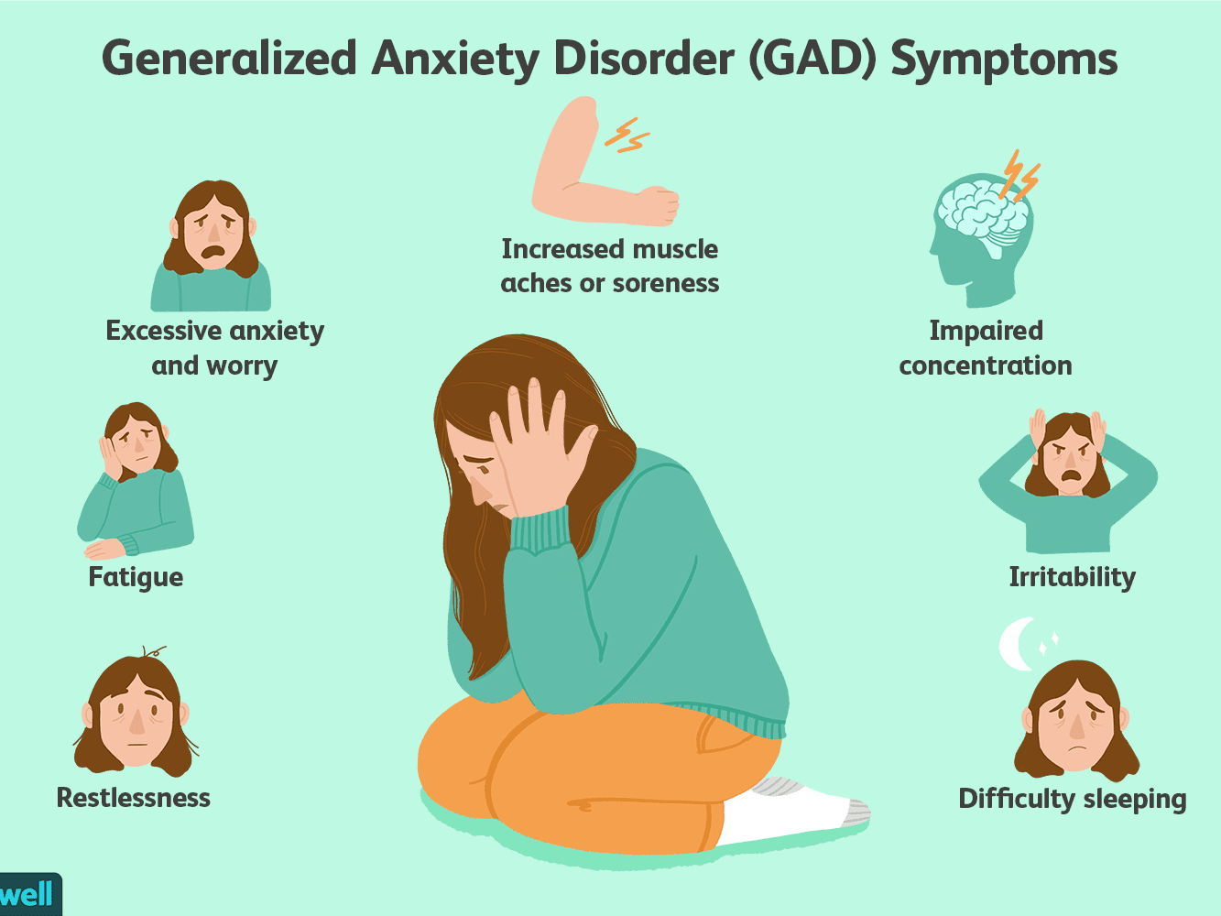
AD Bipolar Disorder
Bipolar disorder is a mental disorder that causes people to experience noticeable, sometimes extreme, changes in mood and behavior. Sometimes children with bipolar disorder feel very happy or “up” and are much more energetic and active than usual. This is called a manic episode. Sometimes children with bipolar disorder feel very sad or “down” and are much less active than usual. This is called a depressive episode.
Bipolar disorder, which used to be called manic-depressive illness or manic depression, is not the same as the normal ups and downs every child goes through. The mood changes in bipolar disorder are more extreme, often unprovoked, and accompanied by changes in sleep, energy level, and the ability to think clearly. Bipolar symptoms can make it hard for young people to perform well in school or to get along with friends and family members. Some children and teens with bipolar disorder may try to hurt themselves or attempt suicide.

