The regions of the Czech Republic
The country is divided into 14 regions.
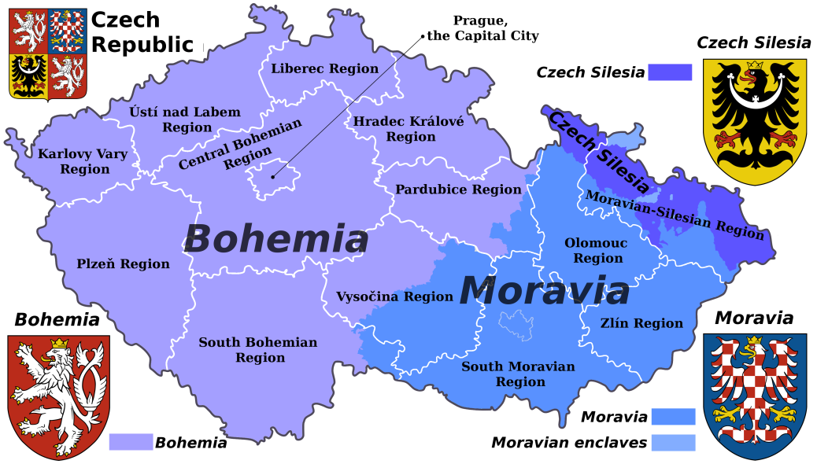

Prague is a treasure of all architectonic styles. Tourists mainly admire the city’s historic buildings and music performed in the historic halls. The Romanesque period is represented by the Basilica of St George at Prague Castle or the ruins of the Royal residence of Přemyslids at Vyšehrad. The most important buildings of the Gothic period are St Vitus Cathedral at Prague Castle, the Old Town Hall on the Old Town Square, Charles University and Charles Bridge with 30 statues from the Renaissance and Baroque periods. There are beautiful Renaissance palaces in the Little Town. Unique Prague Baroque is represented by St Nicholas’ Church or Černín Palace and the Prague Loretto on Hradčanské Square. The National Theatre and National Museum are neo-Renaissance buildings. There are also some very interesting Art Nouveau buildings, e.g. the Municipal House on Republic Square.

South Bohemia is a region of numerous lakes and picturesque villages with very typical architecture. The Šumava Mountains with the Boubín Virgin Forest, Lužnice and Vltava rivers and numerous lakes are a magnet for all nature lovers.
České Budějovice has a large quadratic square with valuable Renaissance and Baroque citizens houses. Another striking landmark is the Gothic-Renaissance Black Tower (72 metres high).
Český Krumlov is famous for its beautiful Renaissance Castle built on a high rock over the town. Brown bears live in the castle moat. There is an open-air theatre with a revolving auditorium there. Both Krumlov and Budějovice are very attractive medieval towns.
Tábor was built on the site of an older town and castle in 1420 by the Hussites and was named after the biblical mountain Tábor. It used to be the centre of Hussite Movement. It has a lot of historical buildings, e.g. the Old Gothic Town Hall with Renaissance gables, a Gothic Church, preserved remains of the fortifications and bastion, Kotnov Castle from the 14th century. There is also the Jordán Pond, the oldest valley reservoir from1492. Hluboká, built in English Tudor style, houses the Mikoláš Aleš Art Gallery.

West Bohemia is a region of world-famous spa towns – Karlovy Vary, Františkovy and Mariánské Lázně. Each year thousands of patients from all over the world come to take waters for drinking cures, baths or inhalations to improve their health. Tourists can also enjoy the beautiful colonnades. The area around Karlovy Vary is famous for china and cut glass.
Cheb is a medieval town founded in the 13th century. The most famous sight in Cheb is “Špalíček”, a group of little Gothic houses belonging to Jewish shopkeepers from the 16th century.

East Bohemia is the region of the Giant Mountains which is a national park since 1963. The main mountain centres there are Špindlerův Mlýn, Pec pod Sněžkou and Harrachov.
There is a very interesting Safari ZOO in Dvůr Králové and Pardubice is known for gingerbread making.
All visitors will be impressed by the sandstone formations in Bohemian Paradise.
Kutná Hora with a wonderful Gothic church of St Barbara, is the most valuable town preserve after Prague. It was a royal town in the Middle Ages where silver was found and mined and coins were made from it.

South Moravia is a region of vineyards and folk architecture and customs.
Brno is the metropolis of Moravia, a seat of Masaryk University. It has a well-known exhibition ground where trade fairs take place. There are architectural monuments from all historical periods. The Gothic Cathedral of St Peter and Paul dominates the city. A grim history surrounds the old Gothic and later Renaissance Špilberk Castle (rebuilt in the 17th century into a fortress) which later served as a state prison. A few kilometres north of Brno you can visit the Moravian Karst, a natural wonderland with the Punkva Cave and the Macocha Abyss.
Telč, a UNESCO town, is typical of the Renaissance period; there is a chateau and a square lined with Renaissance houses with arcades.

North Moravia is a region of industrial towns as well as mountain ranges. Ostrava is the largest town in Northern Moravia. In the second half of the 19th century Rotschilds built Vítkovice there. Ostrava used to be a city of coal-mining and the iron and steel industries.
The nearby Jeseníky and Beskydy Mountains form popular recreation areas with plenty of walking trails. They also convert into excellent ski slopes in winter. The Jeseníky Mountains were declared a nature reserve because of their unique flora.
The Beskydy are situated on the Moravian-Silesian-Slovak border. The main places that people visit are Lysá hora (the highest peak), Radhošť and Pustevny with beautiful wooden houses built by the architect Jurkovič. Tourists also often go down to the Valachian open-air museum of folk architecture in Rožnov pod Radhoštěm that shows how life used to be.
Štramberk is a small town near Nový Jičín. Its centre is a historical town reserve. Below the round tower called Trúba (a part of former castle) lies the square with its Baroque houses. There is a cave called Šipka, in which the skeleton of a Neanderthal man was found in the 19th century, as well as the bones of a mammoth and rhinoceros, tools and a fireplace, amongst other things.
Olomouc, the largest town preserve after Prague, is a cultural centre of Moravia. The last male member of the Přemyslid dynasty, King Václav the Third, was murdered at Olomouc Castle in 1306. It is the seat of the Palacký University. There are many valuable sights such as the ruins of the Romanesque Palace of Přemyslides, the Gothic Cathedrals of St Wenceslas and St Maurice and the Renaissance Town Hall with an astronomical clock. The Baroque Holy Trinity Column has been put on the UNESCO list.

