**Homework from BACTA**

**1) Your opinion about Tourism, Travelling, Advantages and disadvantages of tourism, Problems of Tourism** (Word,2 page)

**2) Find selected tourism statistics in your chosen destination** (Word, 2 page)

**3) Propose a package tour for 3 days (accommodation, transport, food, sights) –** Powerpoint presentation – 15 minutes

**4) Introduce 2 Specific Types and forms of Tourism** – (Cultural Tourism, Gay tourism or LGBT tourism, Medical, Spa tourism, Religious, Wildlife tourism, Sports, Space tourism,….see Fig.1) – (Word, 2 page)

**Fig. 1: Types and forms of Tourism**

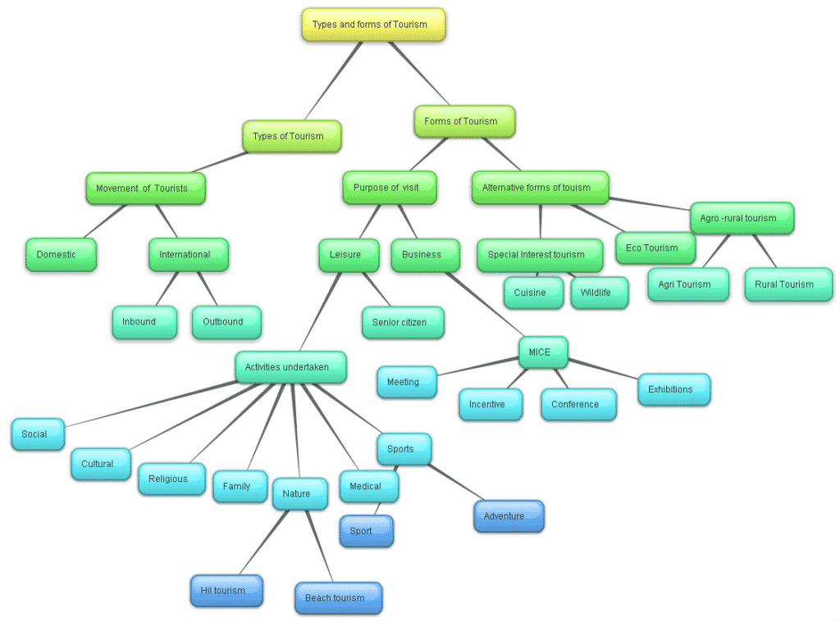

**Source:** **https://tourismnotes.com/travel-tourism/**