Click and enter the title of the seminar paper

Seminar paper for the course:

Click and enter text.

First and last name: Click and enter your first and last name.

Field of study/program: Click and enter the name of the field/program.

Form of study: Select an item.

Karviná Click and enter the year.

Contents:
Introduction 1
1 Notes on the seminar paper 2
1.1 MS-Word 2
1.2 Structure and formats 2
2 Example of embedded objects 3
Conclusion 4
References 5
List of tables 5
List of figures 5

Introduction
The aim of the seminar paper, the choice of the topic or problem to be solved, the outline of the seminar paper procedure, the choice of tools for solving the problem, etc.

Notes on the seminar paper

MS-Word
Basic video help is available on the official Microsoft website: https://support.microsoft.com/en-us/word.

Structure and formats
Make sure your paper style is consistent, uniform, using a single style of numbered and unnumbered bullets. When writing, use the predefined styles:
- Body text – for the basic style of text paragraphs.
- No Spacing – space-saving style for tables.
- Heading 1
- Heading 2 - don't unnecessarily segment the text.
- Heading 3 – don't unnecessarily segment the text; use it except for large-scale seminar papers.
- Subtitle – use it for better clarity and structure of the text - the heading will not be part of the automatically generated content.
- Quote - for direct quotes in the text.
- Source - style for listing the source under the embedded objects.
- References - style for citation sources: list format.
  - Content
The content is generated automatically. Update content: right-click and select: "Update field".
  - embedded objects
Table and graph captions need to be placed above the object and below the object with the source designation. If you have created a graph or table during the processing of the seminar paper (you are the author), state in the source: "Source: own."
  - References
The method of citing and creating publication sources is described in the Dean's Instruction No. 02/2020.

Example of embedded objects

Table 1: Table of comparison of inflation in selected years between the Czech Republic and the Slovak Republic. [in%]
 | 2004 | 2005
CR | 2,8 | 1,9
SR | 7,4 | 2,8
Source: HOLÁSKOVÁ, P., 2009. Vývoj inflace a nezaměstnanosti v ČR ve srovnání se státy EU [online]. Brno: bakalářská práce, Masarykova univerzita, Pedagogická fakulta, s. 40. Ing. Oldřich KRÁLÍK, CSc. [vis. September 29, 2021]. Available at: https://is.muni.cz/th/om3ke/Vyvoj_inflace_a_nezamestnanosti_v_CR_ve_srovnani_se_staty_EU.doc

Figure 1 Graph of gold price development over 10 years as of 09/2021 [in USD].
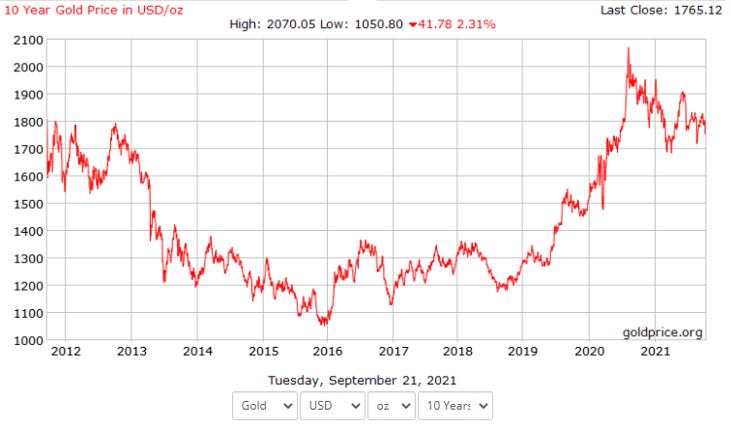
Source: Gold Price Group, 2021. 10 Year Gold Price in USD/oz. GoldPrice.Org [online]. Dallas: Gold Price Group, c2002-2021 [vid. September 29, 2021]. Available at: https://goldprice.org/charts/history/gold_10_year_o_usd_x.png

Conclusion
A summary in connection with the introduction: evaluation of the achievement of goals, possibilities for further development, deviations from the procedures originally set out in the introduction, etc.

References
- TÝČ, V., 2006. Základy práva Evropské unie pro ekonomy. 5th ed. Prague: Linde. ISBN 80-7201-631-8.
- JONES, R. J., 2001. The politics and economics of the European Union: an introductory text. 2nd ed. Cheltenham: Edward Elgar Publishing. ISBN 1-84064-110-X.
- HINDLS, R., S. HRONOVÁ, J. SEGER a J. FISCHER, 2007. Statistika pro ekonomy. 8th ed. Prague: Professional Publishing. ISBN 978-80-86946-43-6.
- OECD, 1993. OECD Employment Outlook 1993 [online]. Paris: OECD [vis. August 24, 2014]. Available at: http://www.oecd.org/dataoecd/59/22/2485426.pdf
- BASL, J. a J. POUR, 2006. Kvalita podnikové informatiky v kontextu informační společnosti [online]. Working paper CES VŠEM No. 10/2006. Prague: VŠEM [vis. August 3, 2012]. Available at: http://www.vsem.cz/data/data/ces-soubory/working-paper/gf_WPNo1306.pdf
- ČNB, 2018. Výroční zpráva 2017 [online]. Praha: Česká národní banka vis. August 3, 2018]. Available at: https://www.cnb.cz/cs/o_cnb/hospodareni/vyrocni_zpravy/vyrocni_zprava_2017.pdf

List of tables
If they are none, delete them including the heading. Generate the list using MS-Word tools ("References" tab of the "Insert Table of Figures" function).

Table 1: Table of comparison of inflation in selected years between the Czech Republic and the Slovak Republic. [in%] 3

List of figures
If they are none, delete including the heading. Generate the list using MS-Word tools ("References" tab of the "Insert Table of Figures" function).

Figure 1 Graph of gold price development over 10 years as of 09/2021 [in USD]. 3

