**Mathematics in Economics – lecture 9**

**Indefinite integral**

Integration is a reverse procedure to differentiation.

Notation:



Legend: …. Integration sign – indefinite integral; *f*(*x*) …. Integrated function;

*F*(*x*) … antiderivative of *f*(*x*); …*C* …. Integration constant

Indefinite integral is a linear operator:





We compute integrals with the use of formulas above, and with the use of the table of elementary integrals:

**Indefinite integral – elementary integrals**



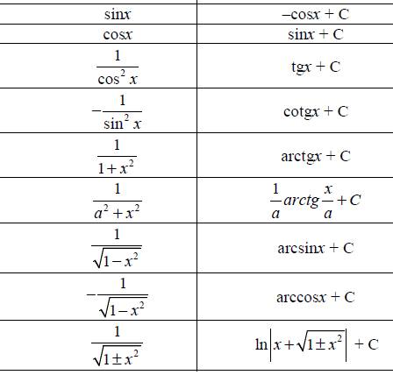

**Indefinite integral - examples**

1)

2)

5)

6)

**7)**



8)



9)



10)



**Indefinite integral – integration methods**

For more complicated integration we use suitable integration methods:

* Substitutions
* Method per partes

All these methods will be demonstrated on examples.

1. **Integration by a substitution**

We use a substitution typically in the following cases:

* When an integrand contains an internal function.
* When an integrand contains lnx or exp(x).
* When an integrand contains goniometric functions.
* When an integrand contains square roots.

Problem 1





A note: We substitute not only an integrand, but also dx!

Problem 2





Problem 3





Problem 4





Problem 5





Problem 6 Usually, we substitute (square roots).





Problem 7





**HOMEWORK**

A] 

B] 

C] 

D] 

E]  F]

1. **Integration by parts (per partes method)**

Per partes method (integration by parts) is used for integration of a product of two functions.

Let *u*(*x*) and *v*(*x*) be two functions. Then, we obtain:









The last formula is “per partes“ formula.

Problem 1





Note: a choice of *u* and *v´* is important. An incorrect choice leads to a growing difficulty of a problem.

Problem 2





Problem 3





**HOMEWORK**

A]

B]

C]