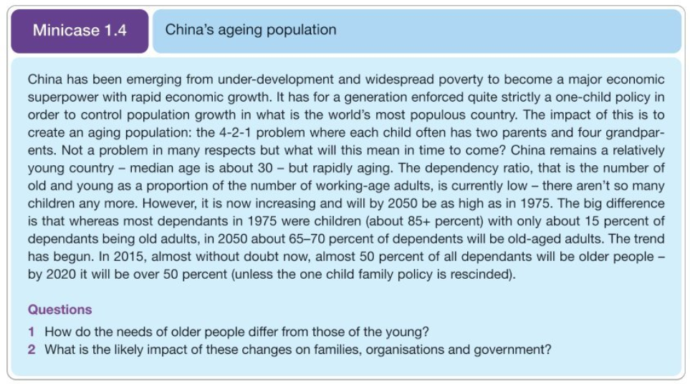

**Case study questions**

1. **How do the needs of older people differ from those of the young?**
2. **What is the likely impact of these changes on families, organisations and government?**

* **For the second question let’s think about two scenarios:**

1. China did relax the child policy from 2015 allowing married couples to have up to 2 children and from 2022 up to 3 children.
2. China did not relax the child policy and all the couples are allowed to have only 1 child.

* Answer the second question for each scenario.