Expected value
1)
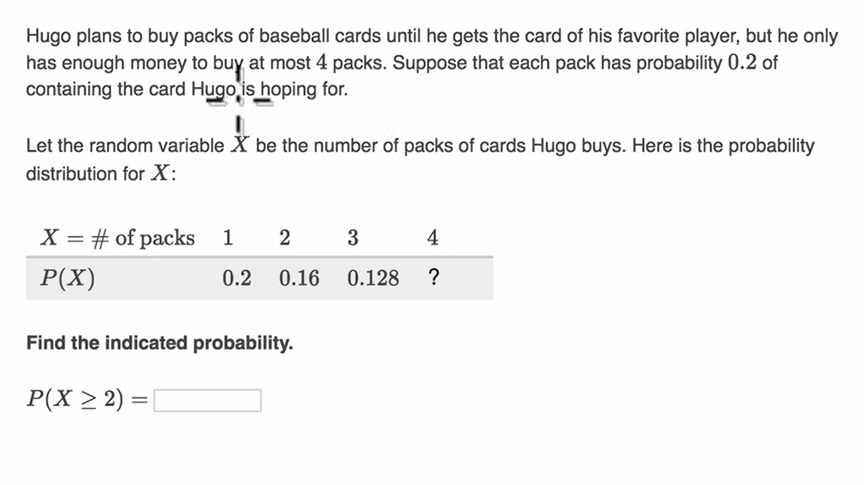2)
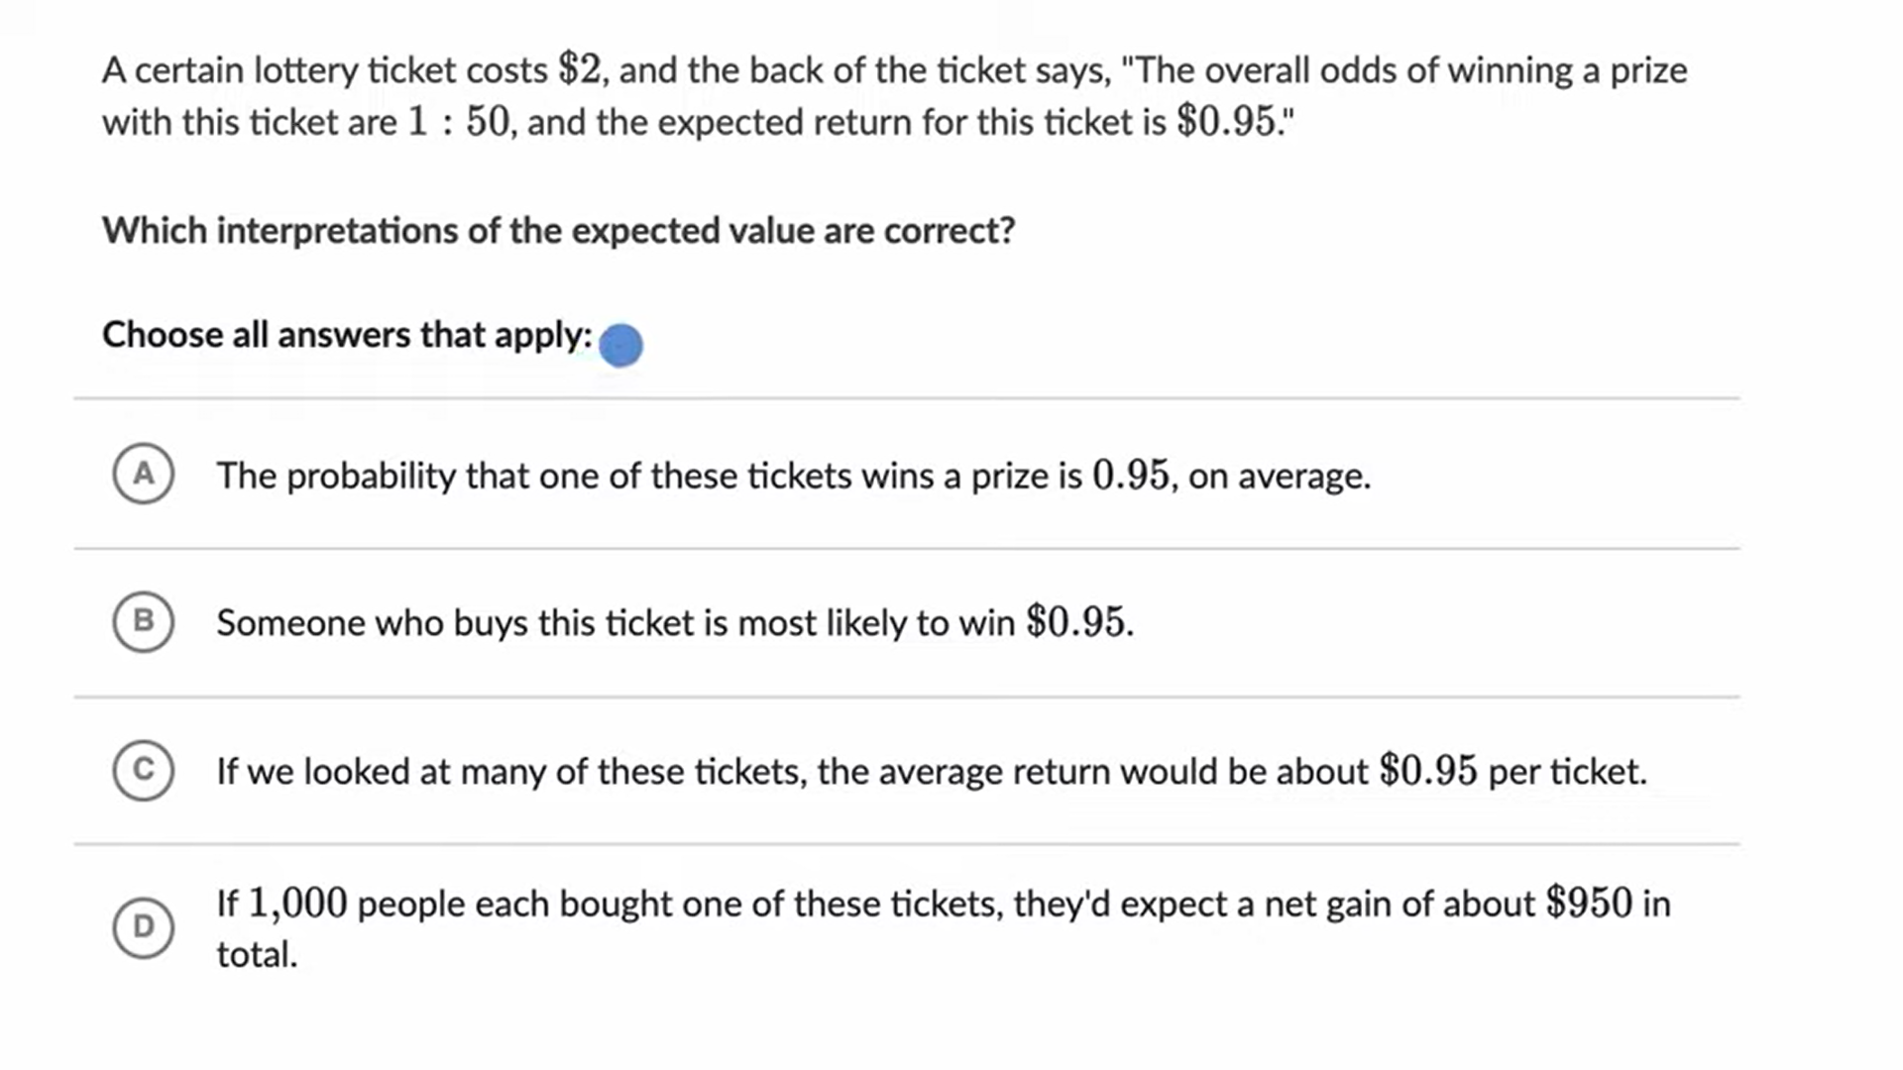
3)
A construction company is considering submitting bids for two contracts. It will cost the company ‍$10,000 to prepare and submit the bids, and if won, each bid would produce $50,000 of income to the company. The company estimates that it has a 10% chance of winning any given bid.
Here is the probability distribution of X = the number of bids the company wins, and M = the amount of money the company profits from the bids.
X = the number of bids won | 0 | 1 | 2
M = profit
Probability

Calculate the mean of M.
4)
5)
