Exam Test of Managerial Accounting

Name and Surname:……………………… ID number:…………………..
Select the correct answer (5 x 2 point)
- Management accounting shall be governed by:
a) no law
b) the Act on Accounting
c) the Income Tax Act

- The economic concept of costs works with:
(a) opportunistic costs
(b) fixed costs
(c) variable costs

- Cost classifications for assigning costs to cost objects include
- manufacturing costs and nonmanufacturing costs
- direct costs and indirect costs
- operating costs and financial costs

- The price at which business performance between internal centers is valued in the production process is called:
(a) transfer price (internal price)
(b) the selling price
(c) market price

- Profit is not affected by:
- revenues
- expenses
- income

Fill in the correct answer (5 x 2 points)
- Among the external users of accounting information we can include, for example 1………….………..………, 2………….…..………….. and 3…………..……………

- The company is at a break-even point. The cost is CZK 40,000. What is the amount of income and profit?

- ……………………………………………………is a detailed plan for the future that is usually expressed in formal quantitative terms.

- Three pillars of managerial accounting are: 1.………………………………., 2…………………………………….. and 3…………………………………………….

- …………………………………………………… is the amount remaining from sales revenue after variable expenses have been deducted

Exercise 1
Production costs are CZK 200, 000. The company produced 30, 000 products and sold 20,000 products. Total sales are CZK 300, 000.
- calculate the company's profit or loss, return on costs and return on sales

Exercise 2
The following unit cost calculation (CZK / pc) is currently valid for the ABC product in the company:
CZK/unit (piece)
Sales price of the product | 1 000
- Variable costs | 600
= Payment allowance | 400
- Fixed costs allocated to the product | 240
= Profit per product | 160

This calculation is valid for a product (and sale) of 100,000 products.
The company's management is considering a new situation where we managed to acquire a new large customer and agree with existing customers to increase deliveries, which could lead to a doubling of the number of manufactured pieces. However, the condition is to reduce the price to CZK 800 / pc.
The increase in production necessitated an increase in total fixed costs by 50 %, mainly due to the necessary expansion and modernization of production. Increasing production and modernizing the process (volume discounts and increasing labor productivity) will also have an impact on reducing unit variable costs by 20 %.

Assignment:
- Determine a unit calculation for the new situation
- Determine the original total profit.
- Determine the new total profit.
- Determine the change in total profit.
- Calculate the original break-even point.
- Calculate the new break-even point.
- Calculate the break-even point change.

Exercise 3
ABC company produces special jackets. The price of one jacket is CZK 2 600 and its production requires CZK 900 of unit material, CZK 240 of unit wages, CZK 190 for variable production overheads and CZK 130 for variable sales overheads. The budgeted fixed overhead costs of the company are: production fixed overheads CZK 2,400,000 and sales fixed overheads CZK 1,900,000.
- Establish a sales, cost and profit budget for an estimated sales volume of 10,000 jackets.

Exercise 4
The administrator of Azalea Hills Hospital would like a cost formula linking the administrative costs involved in admitting patients to the number of patients admitted during a month. The Admitting Department’s costs and the number of patients admitted during the immediately preceding eight months are given in the following table:
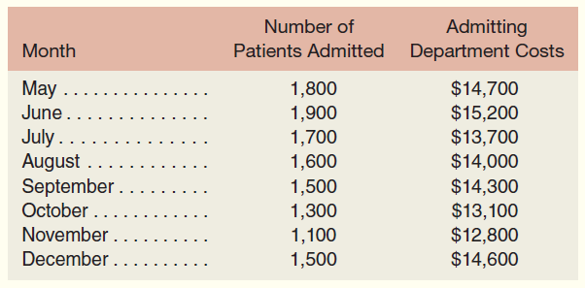

- (1) Use the high-low method to estimate the fixed and variable components of admitting costs.

- (2) Express the fixed and variable components of admitting costs as a cost formula in the form

