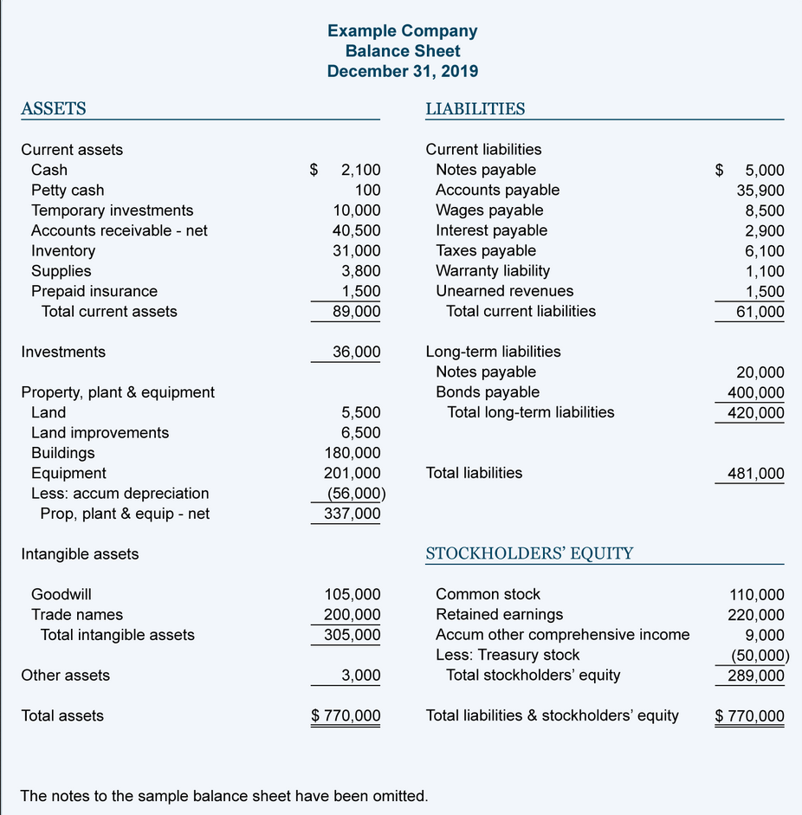

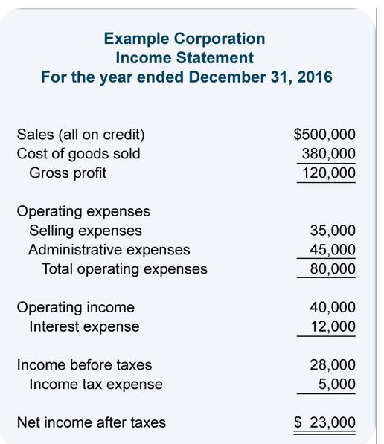

**Exercise 1**

From the following:

• prepare a balance sheet and calculate the share capital

• prepare an income statement

• calculate profit or loss.

**Items:**

* Accounts receivable CZK 245,000
* Goods 300,000 CZK
* Interest expense CZK 3,000
* Buildings 800,000 CZK
* Long-term bank loans CZK 340,000
* Wages payable CZK 230,000
* Selling expenses CZK 12,000
* Sales 950, 000 CZK
* Cash 45, 000 CZK
* Accounts payable CZK 270,000
* Bank accounts CZK 760,000
* Repairs CZK 25,000
* Equipment 56, 000 CZK
* Cost of goods sold 500, 000 CZK
* Depreciation CZK 40, 000
* Share capital = ????

|  |  |  |  |
| --- | --- | --- | --- |
| **Balance sheet in thousands of CZK** | | | |
| ***Assets*** | | ***Liabilities*** | |
|  |  |  |  |
|  |  |  |  |
|  |  |  |  |
|  |  |  |  |
|  |  |  |  |
|  |  |  |  |
|  |  |  |  |
|  |  |  |  |
|  |  |  |  |
|  |  |  |  |
| **Total assets** |  | **Total liabilities** |  |

|  |  |  |  |
| --- | --- | --- | --- |
| **Income statement in thousands of CZK** | | | |
| ***Expenses*** | ***CZK*** | ***Revenues*** | ***CZK*** |
|  |  |  |  |
|  |  |  |  |
|  |  |  |  |
|  |  |  |  |
|  |  |  |  |
|  |  |  |  |
|  |  |  |  |
|  |  |  |  |
|  |  |  |  |
| **Total Expenses** |  | **Total Revenues** |  |
| ***Profit or loss*** | | |  |

**Exercise 2**

Production costs are CZK 100, 000. The company produced 15, 000 products and sold 10,000 products. Total sales are CZK 150, 000.

* calculate the company's profit or loss, return on costs and return on sales

**Exercise 3**

Production costs are CZK 100, 000. The company produced 15, 000 products but sold only 10,000 products. Total sales are CZK 150, 000.

* calculate the company's profit or loss, return on costs and return on sales

**Exercise 4**

In the monitored period, the company incurred total costs of CZK 200 (material consumption 80, wages and insurance 50, depreciation 40, purchased services 30). At these costs, the company produced 20 products. During this period, the company sold 16 products at a market price of CZK 12 per piece (price without VAT).

* Calculate the company´s profit or loss
* Calculate return on costs
* Calculate return on sales

**Exercise 5**

In the monitored period, the company produced 20 products. The company incurred total costs of CZK 200 (consumption of basic materials, wages and insurance of executives, depreciation of production equipment, purchased services). The total cost of 24 products sold was CZK 240. The market price of one product is CZK 12.

* Calculate the company´s profit or loss
* Calculate return on costs
* Calculate return on sales