NAME(S):………………………………………………………………………………………

The most valuable brands in the world
As you probably know, brand equity is becoming increasingly important factor to successful brands. Brand equity has the ability for firms to gain additional market share, at a price premium, with increased customer loyalty, and greater acceptance of new products. It also provides significantly more access to more retailer channels and easier ability to enter new markets.
Here are the top 15 brands for 2020 as determined by BRANDZ.
- Amazon
- Apple
- Microsoft
- Google
- Visa
- Alibaba Group
- Tencent
- Facebook
- McDonalds
- Mastercard
- AT&T
- Verizon
- CocaCola
- IBM
- Marlboro

ACTIVITY/TASK
- Most professional brand valuation firms consider the impact of brand’s contribution to overall profitability to measure brand equity, rather than softer emotional metrics, such as likability – do you agree with this profit-focused approach?

- Have a look at the top 10 brands in the world, what similarities can you see in regards to their marketing activities?

- Only a few years ago Coca-Cola was the most valuable brand in the world, a position it had held for a long time. Do you think it is possible for Coca-Cola to every regain the number one spot?

- How is it possible that the Marlboro (cigarette) brand is still in the top 15 most valuable brands in the world – given it is prohibited from advertising in many countries? Therefore, to what extent do you think that advertising spend influences overall brand equity?

NAME(S):………………………………………………………………………………………

THE ROLE OF LOGOS

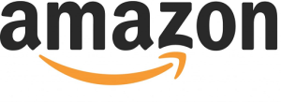
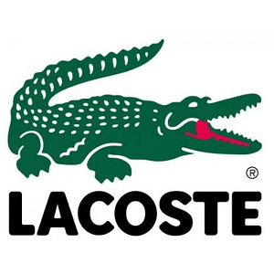
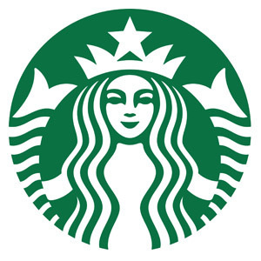

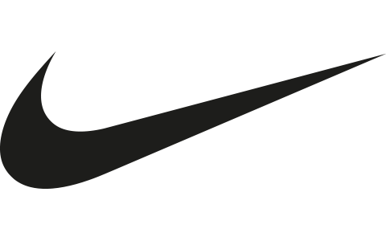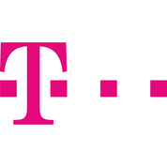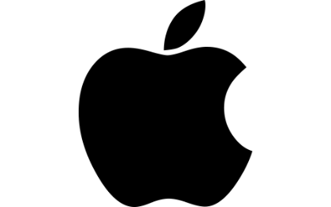

ACTIVITY/TASK
Above there are some well-known logos to review.
- Which logos can you recognize?

- Why do you think that these logos were designed this way? That is, what are they trying to communicate?

- Are logos just used for quick recognition – or do they try to “tell a story” about the brand?

- Which logos, do you think, are the better ones? Why?

- How often (if at all) should successful brands change/fine-tune their logo design?

- In addition to a brand’s logo – what are some other brand elements (colors, shapes, slogans, sounds) that are also important to use?

- Do you think that every brand needs a logo? Or are logos more important in certain industries only?

