NAME(S):………………………………………………………………………………………

SALES PROMOTION TOOLS – B2C
Firms may use a variety of sales promotion tools to help them increase short-term sales. Choosing from the below list of possible tools, identify which one/s would be most appropriate for:
A newly launched chocolate bar
Accommodation in hotel
A woman’s fashion clothing store
ACTIVITY/TASK
 | Sales Promotion Tools | Chocolate bar | Accommodation in hotel | Clothing store
1 | A 20% discount
2 | 20% extra free
3 | A two-for-one deal (1+1)
4 | Discount via a coupon for next purchase
5 | A competition (e.g. win a TV set)
6 | Extra points on a loyalty program
7 | Receive a free gift (if spending more than $X)
8 | Give a free sample
QUESTIONS
- Start this activity by completing the above table.
- Which sales promotion tools did you use the most? Which ones did you use least?
- How effective do you think sales promotions are in generating sales and gaining new customers?
- Is there a danger in overusing sales promotions?

NAME(S):………………………………………………………………………………………

POP/POS DISPLAYS
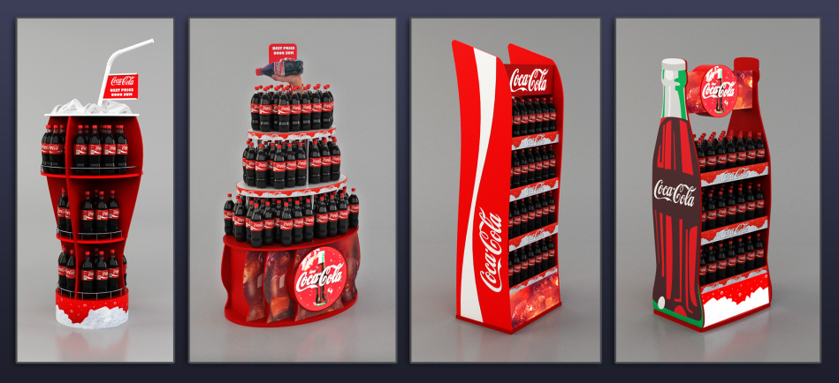
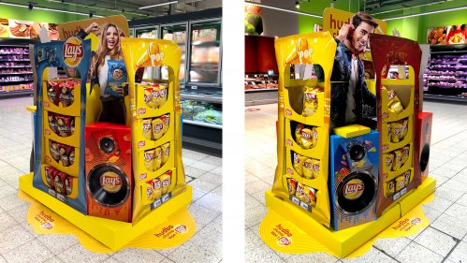
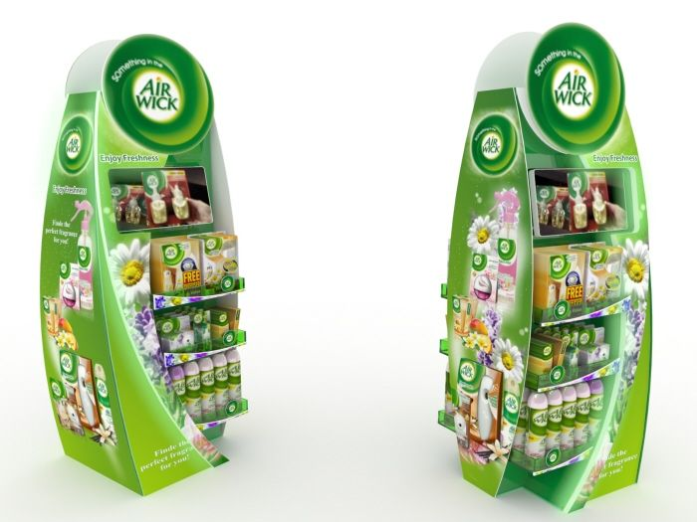

QUESTIONS
- Which of the POP/POS displays above you like the best?

- Try to assess them from the marketing point of view.

