**Exercise 1**

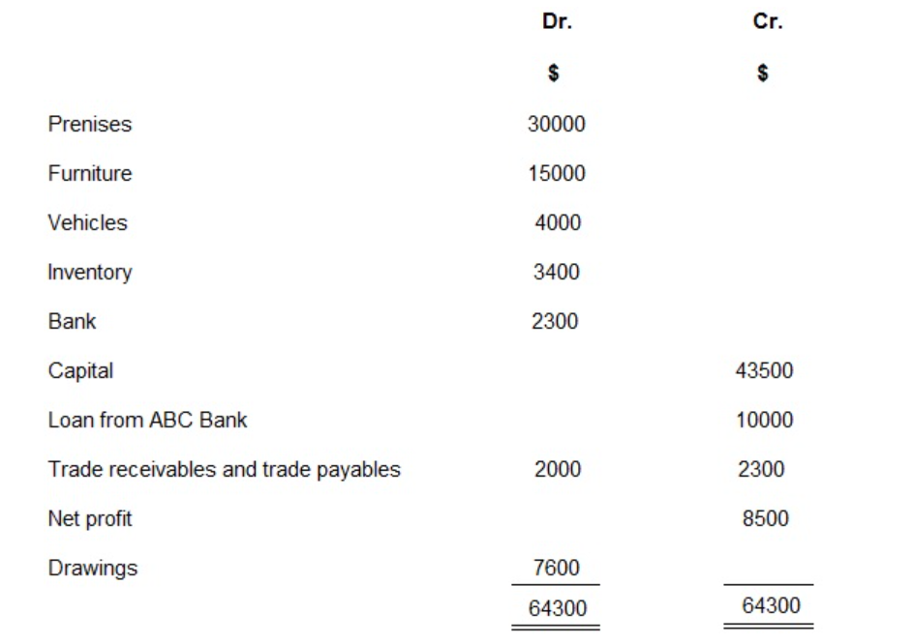

**Required:**

Prepare [balance sheet](https://www.financialaccountancy.org/bookkeeping-and-accounting/balance-sheet/) for F. Green as at 31 March 2015 in both horizontal and vertical style.

**Note:**

In the absence of information about the date of repayment of a liability, then it may be assumed that loan is a non-current liability and a trade payable is a current liability.

**Exercise 2**

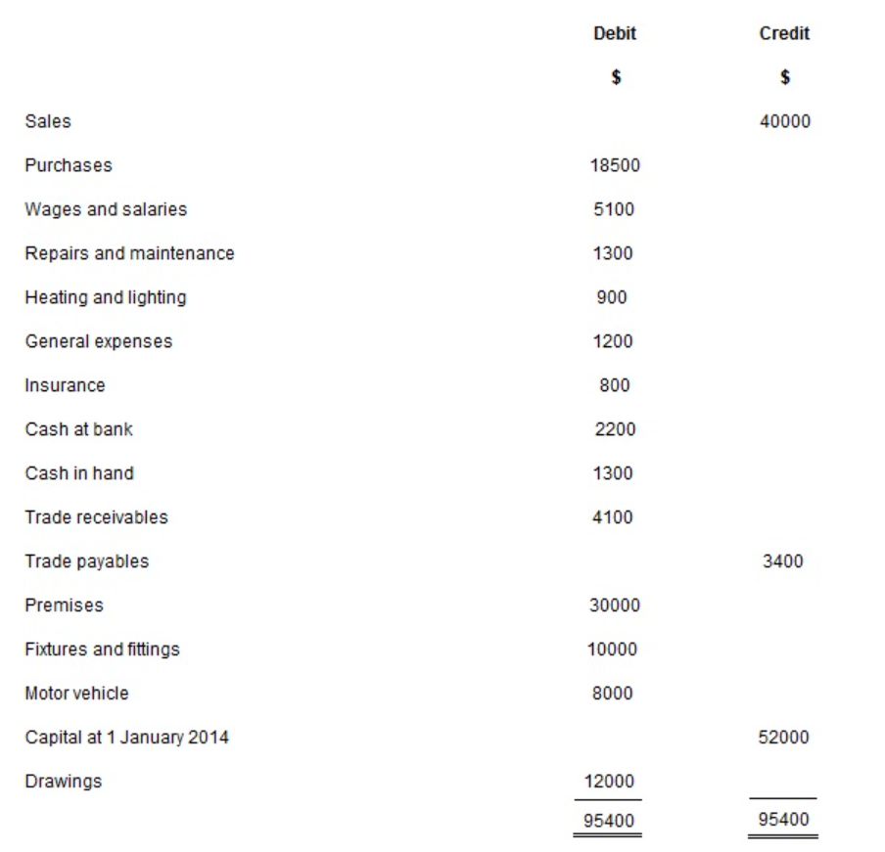

**The following additional information is available:**

Inventory at 31 December 2014 was valued at $4500.

**Required:**

(a) Prepare income statement for the year ended 31 December 2014.

(b) Prepare a balance sheet as at 31 December 2014.

**Exercise 3**

The airline achieved the following results in 2018:

|  |  |
| --- | --- |
| Sales | CZK 300 million |
| Air transport costs (consumption of materials, purchased services, depreciation, labour costs) | CZK 210 million |
| Profit tax | CZK 10 million |
| Net profit | CZK 24,4 million |

The invested capital is CZK 1.2 billion and consists of two thirds of interest-bearing foreign funds, mostly long-term bank loans with an average interest rate of 6.95%. Owners have considered the business risk associated with their investment in this company and the alternative options for investing their capital, and on the basis of these considerations, require an equity appreciation of 11%. The income tax rate is 24%.

* Calculate the amount of economic value added (EVA) and return on equity and interpret the results.

ROE = net profit / equity

Equity = 1/3 of CZK 1.2 billion = CZK 400 million

ROE = CZK 24.4 million / CZK 400 million

ROE = 0.061 * 100 = **6.1%**

EVA = NOPAT - cost of debt - cost of equity

Economic value added = operating profit after tax - cost of debt - cost of equity

Operating profit = 300 - 210 = CZK 90 million

Operating profit after tax (NOPAT) = 90 - 10 = CZK 80 million

Borrowing costs = 2/3 of CZK 1.2 billion = CZK 800 million * 0.0695 = CZK 55.6 million

Cost of equity = 1/3 of CZK 1.2 billion = CZK 400 million * 0.11 = CZK 44 million

EVA = 80 – 55.6 - 44 = **-19.6 mn CZK**

**Exercise 4**

LAK produces transparent wood lacquer. The production is fully automated, the largest cost items are the consumption of basic material (resin, oil, etc.) and depreciation of the production line. It was acquired 4 years ago for 85 000 CZK. And its estimated useful life is 10 years. In the 5th year of using the property, the market price of the production line is set at 90 000 CZK.

* What is the amount of depreciation in the 5th year of depreciation in financial accounting and management accounting?

|  |  |  |
| --- | --- | --- |
| Depreciation in financial accounting | 85 000 CZK / 10 | 8 500 CZK |
| Depreciation in managerial accounting | 90 000 CZK / 10 | 9 000 CZK |

* Financial accounting and financial concept of costs works with the historical price (price on the invoice).
* Managerial accounting and value concept of costs work with the current purchase price.
* The economic concept of costs works with opportunity costs.

**Exercise 5**

The company JENA, which is engaged in manufacturing and business activities, bought goods worth CZK 100,000 at the end of last year. The goods sold for 120 000 CZK. He currently buys the same goods for CZK 106,000. In addition to the possibility to sell these goods, the company is considering that it can also be used as a semi-finished product in a newly manufactured product. The new product, based on preliminary calculations, based on current price ranges, can bring up to 10% cost-effectiveness.

* Express the cost of goods sold based on their financial, value (managerial) and economic concepts and determine the trade margin (profit) from the sale of goods.

***Solution:***

|  |  |  |  |
| --- | --- | --- | --- |
|  | Sales (CZK) | Costs (CZK) | Profit (CZK) |
| financial concept of costs | 120 000 | 100 000 | 20 000 |
| value concept of costs | 120 000 | 106 000 | 14 000 |
| economic concept of costs | 120 000 | 106 000 + 10 % z 106 000 = 106 000 + 10 600 = 116 600 Kč | 3 400 |

10% of CZK 106 000 = revenues from unrealized variant (use of goods as semi - finished products in new production.

**Exercise 6**

Mr. Cross decided to do business as a craftsman. According to various information, he found that he can earn about 500 thousand CZK per year, production and other costs will be 300 thousand CZK. The company has to invest CZK 1 million with an interest rate of 6%. However, business will lose its current monthly salary of 9 000 CZK.

* Calculate accounting profit and economic profit.

***Solution:***

|  |  |  |  |
| --- | --- | --- | --- |
| **Accounting profit (CZK)** | | **Economic profit (CZK)** | |
| Sales | 500 000 | Sales | 500 000 |
| Costs | 300 000 | Costs | 300 000 |
| Interest on financial capital | 60 000 (6 % z 1 000 000) | Interest on financial capital | 60 000 (6 % z 1 000 000) |
| **Accounting profit** | **140 000** | Opportunity costs - lost wages | 108 000 (9 000 * 12) |
|  |  | **Economic profit** | **32 000** |