TOPIC:
- Project Management Triangle
- In practice, develop a project “Tomorrow´s Day”

The Project Management Triangle (also known as Triple Constraint, Iron Triangle and “Project Triangle”) is a model of the constraints of project management. Success in project management has been traditionally associated with the ability of the constraint parameters of projects in scope, time, cost, and quality called iron triangle. It is a popular metaphor pointing out that the project manager is asked to reach a reasonable trade-off among these constraints.
Project managers often require a balancing act between key factors that constrain the overall project delivery. As such, the quality of work is constrained by the project’s budget (funding and resources), deadlines (time) and scope (features). These three factors are the well-known attributes of scope, schedule, and cost as shown in the Figure below:
- Scope refers to the total amount of work involved in delivering the project
- Cost refers to the sum of all resources required to deliver that work
- Schedule reflects the time estimated or allotted to the project’s delivery.
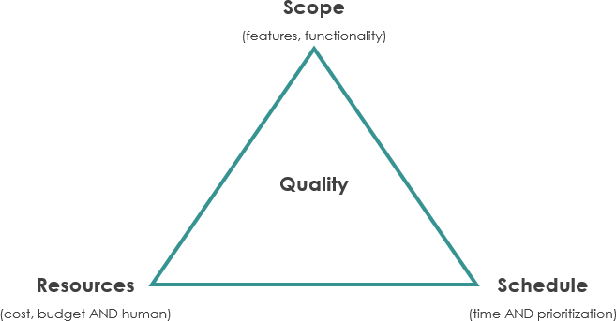
Even if the project manager is allowed to have some flexibility to trade between constraints and obviously, changes in one constraint necessitate changes in others to compensate or quality will suffer. For example, a project can be completed faster by increasing the budget or cutting scope. Similarly, the increasing scope may require equivalent increases in budget and schedule. Cutting budget without adjusting schedule or scope will lead to lower quality. All these scenarios are applying the Triple Constraint for managing the project.
Alternatives to the project management triangle
Project management diamond - The project management diamond is essentially the triangle, but it lists scope and quality as two different factors.
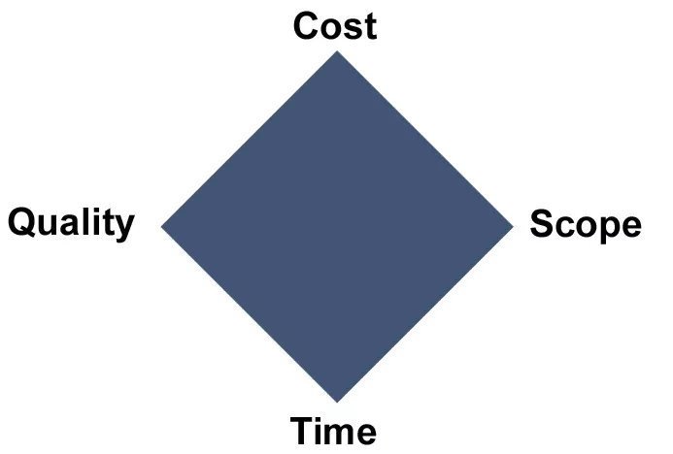
A diamond with the points labelled cost, quality, scope and time. At the centre, people will usually put either ‘expectations’ or ‘customer satisfaction’. Either way, this model prioritises the customer, rather than the product itself.
Project management star
The PMBOK® Guide uses a popular alternative model to the triple constraint. It lists six constraints, made from two overlapping triangles in a star shape. A 6-pointed star with the points labelled schedule, risk, scope, quality, budget and resources As you can see, the project management star also distinguishes between scope and quality. Here, it says scope is constrained by the budget and schedule, while quality is assured by managing risks and resources.
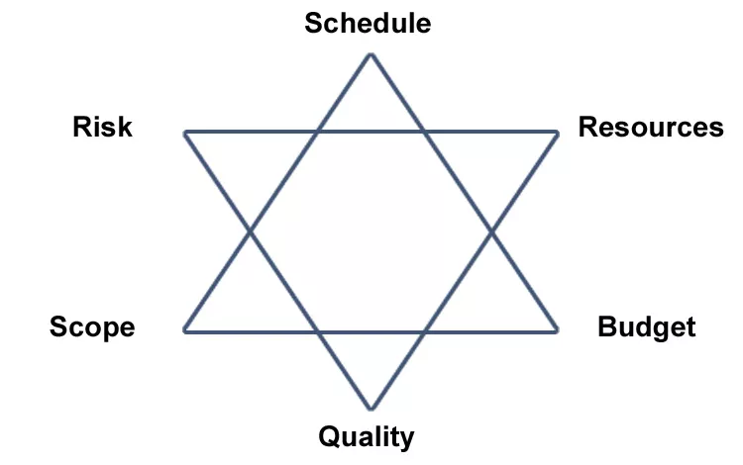
How to manage the triple constraints
Of the three constraints, it is much more important to manage scope. This is why:
- Scope lets the team to know what they’re doing. Even if the deadline is short or the budget is lacking, the project manager can still keep everyone informed, which is necessary to progressing the project.
- Managing scope creep. Clients can change their minds at the last minute, especially since they’re more likely to understand the consequences of cutting the budget or moving a deadline. They may not realise the harm they do when they move the goalposts.
- Withstanding sudden changes in a project. Bringing in more people or throwing more money at the project can actually slow it down. So along with compromising the budget, this can hugely impact the time and scope.
How to determine and apply the triple constraint
This depends entirely on the type of project. The three project constraints need to be discussed in detail with the client before the project starts. They need to know what it will cost in terms of time and scope, as well as budget. You’ll also want to establish that there won’t be any sudden or drastic changes during the project.
Remember that a bad project compromises on all three constraints, and that throwing money and extra time at a project often makes things worse. So stakeholder communication is key. Everyone needs to be fully aware of how the project complies, as the three constraints apply to and affect everyone.
___________________________________________________________________________
Tasks for the 1st seminar:

- In practice, develop a project "Tomorrow's Day":
- Set a goal (quantifiable-SMART)
- Time schedule of the day, logic of compiling a sequence of activities (time + activities)
- Assign resources to activities (personnel, costs - quantified in a currency)
- Project risks

Recommendation:
- Limited time 1 day: start 00:01 - end 24:00
- All activities are focused on achieving the goal (result / benefit that can be verified)
- Cost for all resources (morning breakfast, traveling, activities, shopping, etc.), hidden overheads - energy consumption, housing, services, etc.)
- Summarize the main findings and the overall budget of the project

- Choose the name of your project (for your seminar paper)
- 10 minutes to write down ideas
- Select 3 options
- Determine the "+" and "-" of the selected options (advantages and disadvantages, whether to implement as a project)
- Choose the final idea
_____________________________________________________________________

DON'T FORGET
