Tasks for the 2nd seminar - Develop partial parts (1.1 – 1.5) of your project according to the template of the seminar work!

1. Project definition
1.1. Project name - enter the name of the project
1.2. Default conditions
- They clarify the given problem that needs to be solved, the current situation / state that needs to be solved is defined and described
1.3. Project goals
- Primary goal of the project - the main goal of the project, the SMART criterion
- Secondary objective (s) of the project - sub-objectives of the project, SMART criterion

1.4. Output, result, benefits of the project
- Project output - this is the final "product" of the project (the solution, it can be, for example, a new product, a new service, etc.)
- Result - the result of the change resulting from the outputs
- Benefits - measurable improvement resulting from results

1.5. Organizational structure of the project – short description of organizational structure

1.5.1. Create a diagram of the organizational structure of the project – (For example, use an approach of the Prince2 methodology - Project hierarchy)

  - Project sponsor:
  - Main users of the project:
  - Main suppliers:
  - Project supervision for suppliers / users / company:
  - Project support:
  - Project manager:
  - Team manager (s):
  - Stakeholders of the project:
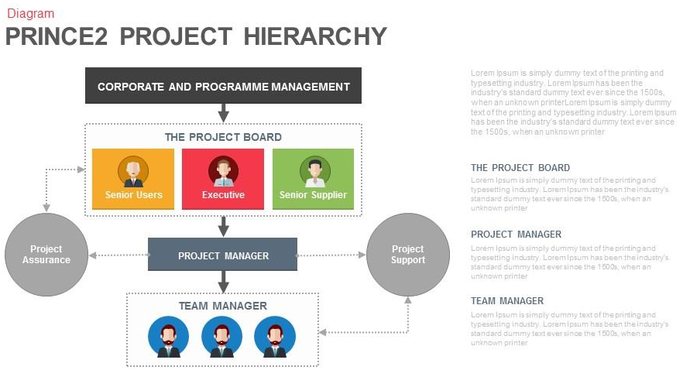

    - RACI matrix - in this phase, first identify the main stakeholders and determine which RACI criteria you will apply (e.g. RACI, RACIS or others). Later, when you have the WBS in the Gantt chart, you will add the main activities and complete the RACI matrix.
___________________________________________________________________________
RACI matrix - assignment and display of responsibilities of individual persons or jobs in a task (project, service or process) in the organization. RACI means:
- R - Responsible - who is responsible for performing the assigned task (implements, is responsible)
- A - Accountable (sometimes also Approver) - who is responsible for the whole task, is responsible for what is done (manages, decides)
- C - Consulted - who can provide advice or consultation for the task (consults, information is requested or waiting for a response to the activity)
- I - Informed - who should be informed about the progress of the task or decisions in the task
- S - Support - provides support during the implementation of activities and participates in the implementation of activities (cooperates)

The general shape of the matrix is:
Work Breakdown Structure (WBS) | Role A | Role B | Role C
Activity 1 | Type of responsibility | Type of responsibility | Type of responsibility
Activity 2 | Type of responsibility | Type of responsibility | Type of responsibility
Activity 3 | Type of responsibility | Type of responsibility | Type of responsibility
… | … | … | …

In RACI, the rule is that only one person has overall responsibility (A-accountability) for a given task (activity). The number of people involved (R-responsibility) should be appropriate with the size and complexity of the task. In the RASCI matrix, only one person has R-responsibility, the others have S-support.
Recommended matrix creation procedure:
- Writing groups of activities for which it is necessary to define responsibility in the rows of the matrix (ideally taken from the WBS from the Gantt chart)
- Writing all important roles into columns of the matrix can be based on a hierarchical organizational structure.
- Enter the types of responsibilities assigned to each cell.
- Check that each activity (line) has an assigned person who is responsible for the task and who performs it.
- Verification that responsibilities for each task are clearly defined and do not overlap.

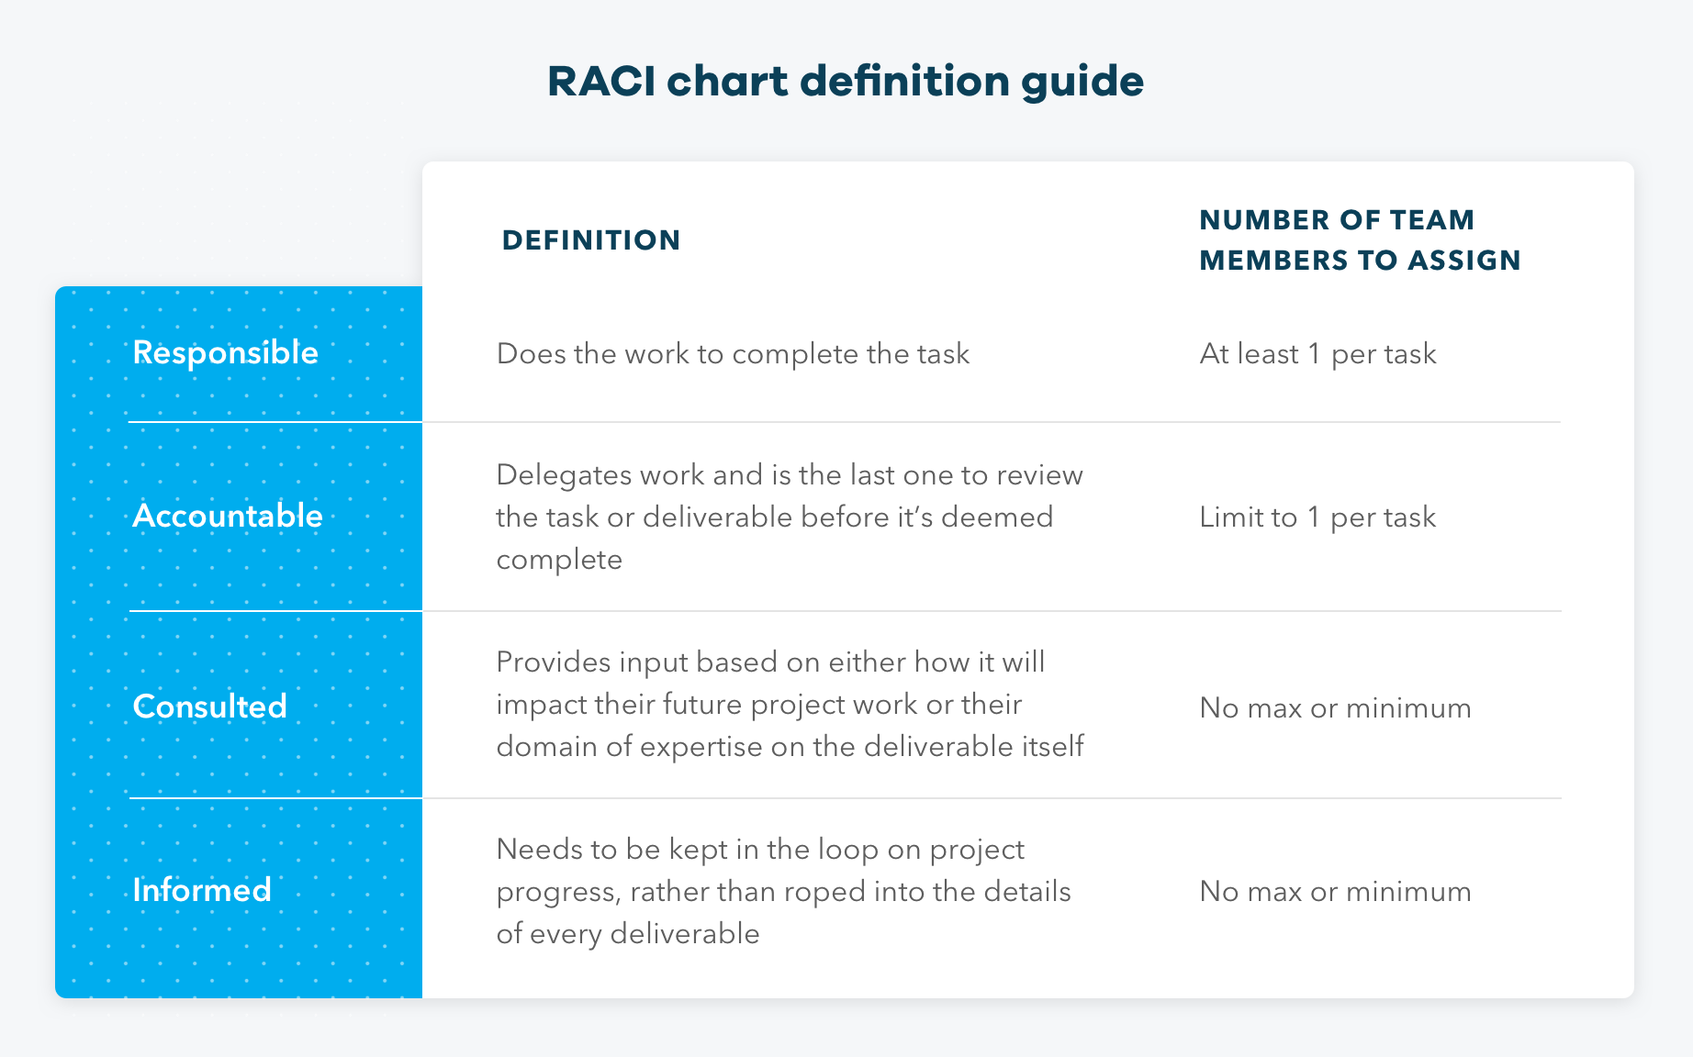

RACI examples
