Tasks for the 4th seminar – Develop partial parts (2.1 – 2.4) of your project according to the template of the seminar work

2. Project structure
2.1. Managerial Summary - Highlights key points that should include important benefits and return on investment

2.2. Reasons for the project - explains the reasons for the implementation of the project, and how the project can achieve business strategies and goals

2.3. Variants (solution options) - listing options such as doing nothing / doing a minimum / doing something. State the rationale and implications of each option.
2.3.1. Do nothing - the current situation (referred to as the zero variant)
2.3.2. Doing a minimum - minimal change, one of the solutions to the problem (not essential)
2.3.3. Do something - a fundamental change that will be addressed by the project, variant, which is decided as the main solution of the project

2.4. Expected disadvantages - characteristics / results that one or more stakeholders perceive as negative. These are not risks, but negative characteristics associated with the option / variant.
___________________________________________________________________________
TIPS for decision making

Decision making is the process of making choices by identifying a decision, gathering information, and assessing alternative resolutions. Using a step-by-step decision-making process can help you make more deliberate, thoughtful decisions by organizing relevant information and defining alternatives.

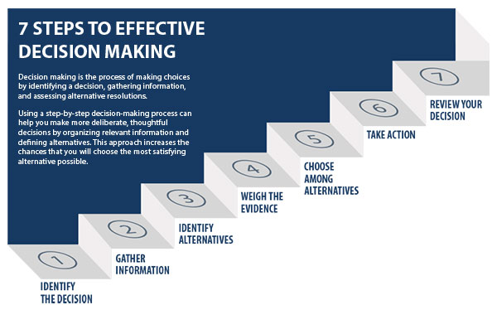
Step 1: Identify the decision
You realize that you need to make a decision. Try to clearly define the nature of the decision you must make. This first step is very important.

Step 2: Gather relevant information
Collect some pertinent information before you make your decision: what information is needed, the best sources of information, and how to get it. This step involves both internal and external “work.” Some information is internal: you’ll seek it through a process of self-assessment. Other information is external: you’ll find it online, in books, from other people, and from other sources.

Step 3: Identify the alternatives
As you collect information, you will probably identify several possible paths of action, or alternatives. You can also use your imagination and additional information to construct new alternatives. In this step, you will list all possible and desirable alternatives.

Step 4: Weigh the evidence
Draw on your information and emotions to imagine what it would be like if you carried out each of the alternatives to the end. Evaluate whether the need identified in Step 1 would be met or resolved through the use of each alternative. As you go through this difficult internal process, you’ll begin to favor certain alternatives: those that seem to have a higher potential for reaching your goal. Finally, place the alternatives in a priority order, based upon your own value system.

Example of the evaluation criteria (basic PROS and CONS with values on the scale can be used) or financial indicators - ROA, ROE, ROS; payback period, CBA analysis, etc.)

Step 5: Choose among alternatives
Once you have weighed all the evidence, you are ready to select the alternative that seems to be best one for you. You may even choose a combination of alternatives. Your choice in Step 5 may very likely be the same or similar to the alternative you placed at the top of your list at the end of Step 4.

Step 6: Take action
You’re now ready to take some positive action by beginning to implement the alternative you chose in Step 5.

Step 7: Review your decision & its consequences
In this final step, consider the results of your decision and evaluate whether or not it has resolved the need you identified in Step 1. If the decision has not met the identified need, you may want to repeat certain steps of the process to make a new decision. For example, you might want to gather more detailed or somewhat different information or explore additional alternatives.

Decision tree – is a simple diagram that illustrates the series of options involved in making decision. It is used as a decision support tool to visualize the decision-making process.
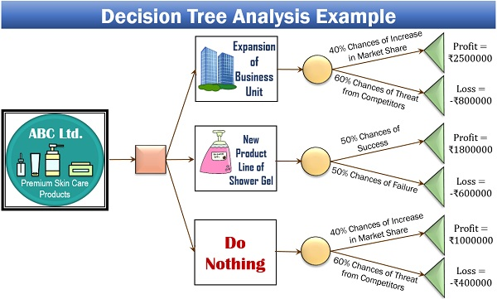
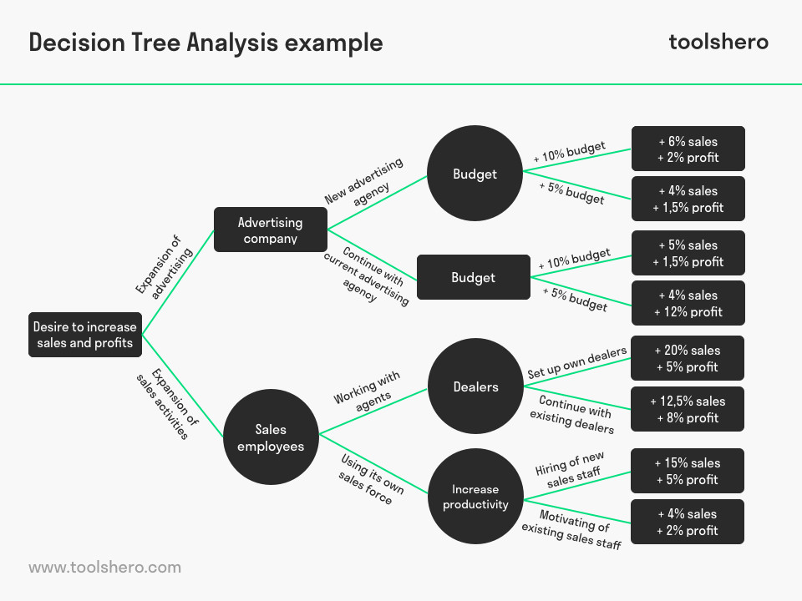
Examples of decision criteria

Example of house purchase – a decision matrix may be used to consider a personal decision such as the purchase of a house. This may be weighted by assigning a different maximum score to each criteria.

