Tasks for the 9th seminar – Develop partial parts: 3. Description of the project product (final project output), and 4. Main risks of the project - according to the template of the seminar work
___________________________________________________________________________
3. Description of the project product (final project output)
3.1. Project product name: (this is, for example, the final product, service, innovation, etc.)
3.2. The purpose of this project product - the purpose that the project product as a whole is to achieve and who will use it.
3.3. Composition - a list of the main products or groups of products to be delivered by the project (e.g. for a car - tires, equipment, model line, etc.)
3.4. Derivation - are there starting materials from which this product is derived? E.g. there are products that will be modified by the project, etc.
3.5. Customer expectations for quality - a description of the expected quality of the project product from the user's point of view, including determination of the standard (specific characteristics of product quality, meeting e.g. testing, functionality, time of use, etc.)
3.6. Acceptance criteria - a prioritized list of measurable criteria to be met in order for the final product of the project to be accepted / accepted.
3.7. Quality tolerances - any tolerances that can be applied to the acceptance criteria
3.8. Responsibility for acceptance - who is responsible for acceptance

TIPS:
• Use creative techniques (e.g. brainwriting, mind map) - what the final product of the project will look like and its composition. There can be a photo of a model, drawing, prototype, etc. The goal is to visualize the project product (product, new service, innovation, etc.). In practice, for example, a physical prototype is made using 3D printing, use your available resources to visualize the project product.
• If it is an innovation, show the final state of the project product (e.g. innovated product-packaging, functional use, design).
• If it is a service (give a description of this service, what it will bring to the user, a description of the process of providing the service, follow-up services, etc.).
• If the product of the project is a process, provide a flowchart of the process (its individual steps, connections, input and output factors, etc.).

4. Main risks of the project
4.1. Risk analysis - RIPRAN method

TIPS for additional study:
Basic principles of the RIPRAN method
The RIPRAN method (see below) is based on the principle of risk engineering, that for risk analysis it is necessary to first determine the following four and prepare their relevant list:
Threat - Scenario - Probability - Loss
Because the number of random events can never be precisely determined, the list cannot be complete. The incompleteness of the list is also caused by knowledge or ignorance of project team members. Therefore, we are talking about a representative list, ie a list that presents all the significant risks that we were able to identify and that we take as a basis for a specific risk analysis.
Let us briefly state the meaning of these terms as understood by the RIPRAN method:
Threat - Danger that is threatening and that is the cause of the harmful consequences and difficulties in the project. (E.g. strong storm, insufficient loan, icing, currency devaluation, strike, dismissal of the project manager, bad subcontracting for the project, ...)
Scenario - The event that we anticipate in the project as a result of the threat. (For example, we will not get a loan - we will not have financial coverage for the project, Franta will fall ill - we will lose the only employee who can do it for our project ...)
Probability - Probability of scenario realization expressed in the interval <0.1>
The probability is related to the duration of the project - resp. to the so-called reference period, when we feel threatened. Note that this is the probability that a scenario with a certain probability is assigned to the threat with a certain probability. It is usually assumed that both phenomena are independent of each other. If the probability of a storm is 0.03 and the probability that when a storm arrives and a construction crane overturns is 0.7, then the resulting probability that we will consider in the relevant case is 0.7 x 0.03 = 0.021
1) E.g. for a strong wind of 11 degrees Beaufort scale in our latitude and d. is probability over one year 0.01, but for 100 years it is 0.63.
2) E.g. laying of cables should take place from March 1 to March 25, then we are interested in the probability of ground frosts in this time period.
Loss - Loss for the project, caused by the implementation of the scenario. We usually express it in monetary units (but we can also say otherwise, the size of the time delay, the loss of workers' lives, etc.). We can add a risk value to each n-tuple.
Risk value = probability x loss
RIPRAN method
The RIPRAN method (RIsk PRoject ANalysis) is a simple empirical method for project risk analysis, especially for medium-sized corporate projects. It is consistently based on the procedural concept of risk analysis. Understands risk analysis as a process (process inputs-process outputs-activities transforming inputs into an output with a specific goal). The method accepts the quality philosophy (TQM) and therefore includes activities that ensure the quality of the risk analysis process as required by ISO 10 006. The method is designed to respect the principles for Risk Project Management described in the IPMA materials.
It focuses on the elaboration of a project risk analysis, which must be performed before the actual implementation. This does not mean that we should not work with threats at other stages. On the contrary, in each phase of the project life cycle, we must perform activities that, on the one hand, gather data for a separate project risk analysis for the project implementation phase, and which evaluate the potential risks of failure of the phase we perform. We will then use the recorded risks for the overall analysis of project risks.
The whole process of risk analysis according to this method consists of four basic steps:
1. Identification of project hazards
2. Quantification of project risks
3. Response to project risks
4. Overall project risk assessment.

Example of a filled table
Number of risk | Threat | Scenario | Note | Probability | Impact on the project | The value of risk | Proposal for action | Expected costs  Deadline for implementation of measures  Personal responsibility (risk owner) | New value  of reduced risk
1. | Occurrence of the influenza epidemic in the spring period March-April. | Almost 30% of employees become ill. | We assume the weather as forecast in the previous year. | 50 % | Failure of work capacity and delay of the contract by 3 months - penalty EUR 600 000. | 300 000 EUR | Flu vaccination | EUR 100 vaccine  Vaccination in January  Agreed with the company doctor - agreed by the employees at workshops | Exceptional diseases will be compensated for overtime - zero risk
2. | …… | ……… | ……… | ….. | ….. | ….
3.
4.

Example of Risk Register
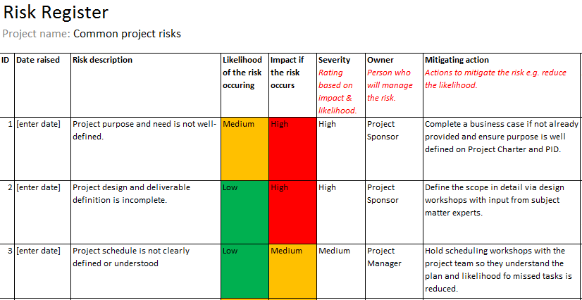

Example of Risk Matrix
