Topic. Current assets
- What are the definition and structure of current assets
- How long is operational, financial, production cycle
- Give the examples of current and fixed assets combination in the manufacturing process.
- What is liquidity? Explain the difference between total, absolute and quick liquidity. which is the most stringent criteria of liquidity?
- How to divide current assets for the fixed and variable part? Which position of current assets is fixed, variable
- List the sources of current assets financing
- Analyze existing types of current assets financing policy
- What are the advantages of current assets
- Ways to avoid the disadvantages of current assets
Task 1
Property of enterprise 75, 45 – fixed assets, 30 – current assets, including 15 – variable part, 15 – fixed. Define the financial resources to provide conservative, aggressive, moderate financing policy
Task 2
Current liabilities 25000, Quick liquidity 0,7, absolute liquidity 0,1, define Duration of the Accounts receivable turnover if revenue is 30000.
Task 3
Current liabilities 25000, Quick liquidity 0,7, absolute liquidity 0,1. Define the value of inventories, if revenue is 30000 and every unit of current assets brings 1,5 hrn.
Task 4
revenue is 20000, profit 2500, cost of production 10000, original value of equipment 22000, balance value 20000, property 30000, equity 22000, Long-term liabilities 500, Accounts payable 5500, Short-term bank credit 2000, 2000 cash, raw materials 3000, finished product 1000, incomplete production 1500, Accounts receivable 2500. Analyze current assets, define working capital.
Task 5
Define total need of current assets for the year and resources of its financing, if:
- Net revenue – 1500 th. hrn.;
- Cost of production sold 950 th. hrn.;
- Sales and administrative expenses – 300 th. hrn.;
- Costs of raw materials purchase 40% from Cost of production sold,
- rate of raw materials 13 days, rate of finished products 9 days, Ratio of incomplete production 20 th. hrn.,
- Duration of the Accounts receivable turnover 18 days,
- Middle operational cash limit 10 th. hrn., insurance amount of money 50% from operational cash limit,
- Profit from other types of activity 50 th. hrn..,
- 40% of net profit goes to the current assets financing,
- Accounts payable 10 th. hrn.,
- current assets at the beginning of the year 450 th. hrn.
Task 6
Define total need of assets, if:
- warehouse and workshop will be leased. Prepayments for the 3 months rent 1,5 th. hrn. Per month;
cost of needed equipment with transportation 30 th. hrn. Cost of installation and adjustment 5 th. hrn.
- rate of raw materials 3 months, rate of finished products 0,5 month.
- Enterprise provides the production of goods, cost of which Per month 65 th. hrn. 28% of cost of production is raw material expenses.
- Needed cash is 6,5 th. hrn.
Define equity, other financial resources if raw materials are financed by Current liabilities
Task 7
Property of enterprise 86, 45 – fixed assets, 41 – current assets, including 11 – variable part, 30 – fixed. Define the financial resources to provide conservative, aggressive, moderate financing policy
Task 8
Current liabilities 40000, Quick liquidity 0,8, absolute liquidity 0,3, define Duration of the Accounts receivable turnover if revenue is 28000.
Task 9
Current liabilities 30000, Quick liquidity 0,9, absolute liquidity 0,3. Define the value of inventories, if revenue is 45000 and every unit of current assets brings 2 hrn.
Task 10
Розрахуйте загальну, швидку, абсолютну ліквідність, ВОК, політику фінансування обраного підприємства для аналітички за 5 остатніх років.

1. Which of the following is a policy or practice that endangers the security of a hospitality firm’s inventory?
a. A physical inventory is taken only once every five years.
b. The accountant who maintains the inventory records may not access the inventory itself.
c. A daily inventory of high-priced items must be taken.
d. There is a separation between the custody of the inventory records and custody of the inventory.
3. Some suppliers absorb the expenses involved in transporting goods to the buyer, but others who deliver will charge the buyer for freight costs. In freight terminology, FOB means:
a. the supplier will charge the buyer for freight costs.
b. the supplier will not charge the buyer for freight costs.
c. free on board, which doesn’t necessarily mean free freight.
d. freight on board, which means the freight charges will be included in the invoice amount.
4. FOB shipping point means that freight charges will be paid by the:
a. hospitality firm that ordered the shipment.
b. purchasing agent.
c. freight company.
d. supplier.
5. Use the LIFO method to value (at cost) the ending inventory. There was no beginning inventory. The purchases during the month were as follows:
5 units @ $2.00 apiece
10 units @ $2.10 apiece
15 units @ $2.20 apiece
If the ending inventory were 15 units, it would be valued under LIFO at:
a. $31.00.
b. $33.00.
c. $64.00.
d. none of the above.
6. The beginning inventory of a certain item for the Frolicsome Resort was 10 units, which were purchased at $10 each. It purchased 5 units at $5 apiece, and later, 3 units at $10 apiece. The resort sold a total of 8 units during the current accounting period. Which of the following inventory valuation methods yields the highest ending inventory value for this inventory item?
a. FIFO
b. LIFO
c. weighted average
d. All these methods yield the same value for ending inventory.

10. Which of the following statements about inventory control systems is true?
a. A physical inventory of all products in storage areas is generally taken once a day.
b. A periodic inventory system indicates how much of each product is on hand by maintaining a running balance of all products entered into and issued from storage areas.
c. A perpetual inventory system eliminates the need for a monthly physical count of items in storage.
d. Staff members who maintain an operation’s perpetual inventory records should also have custody of the inventory itself.

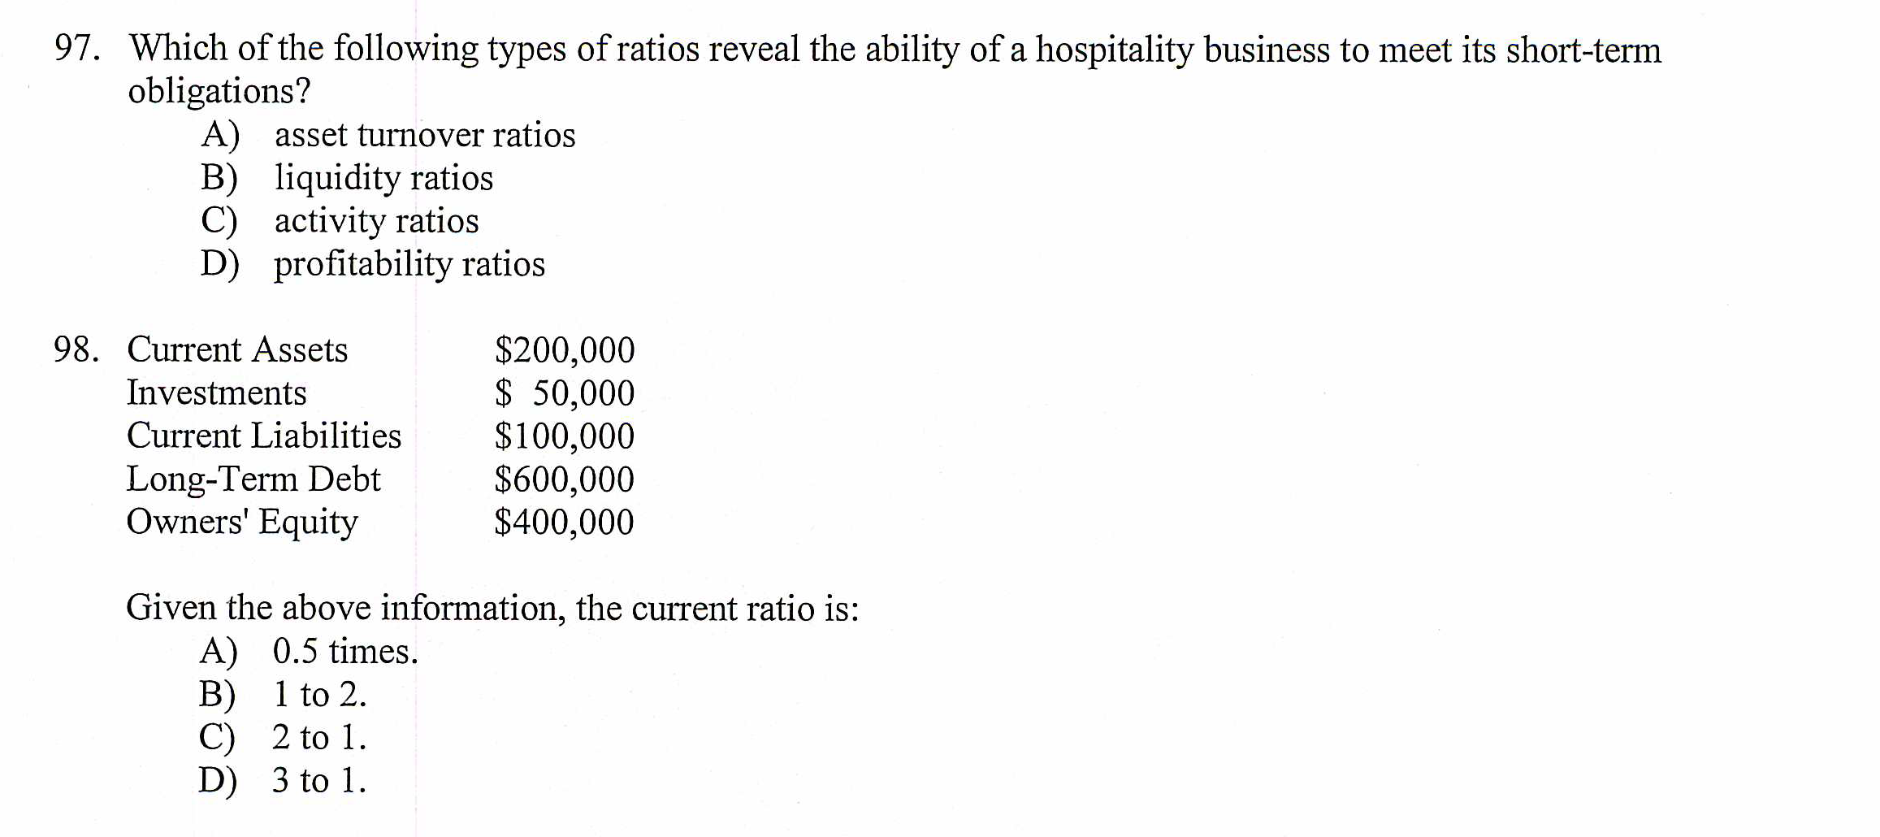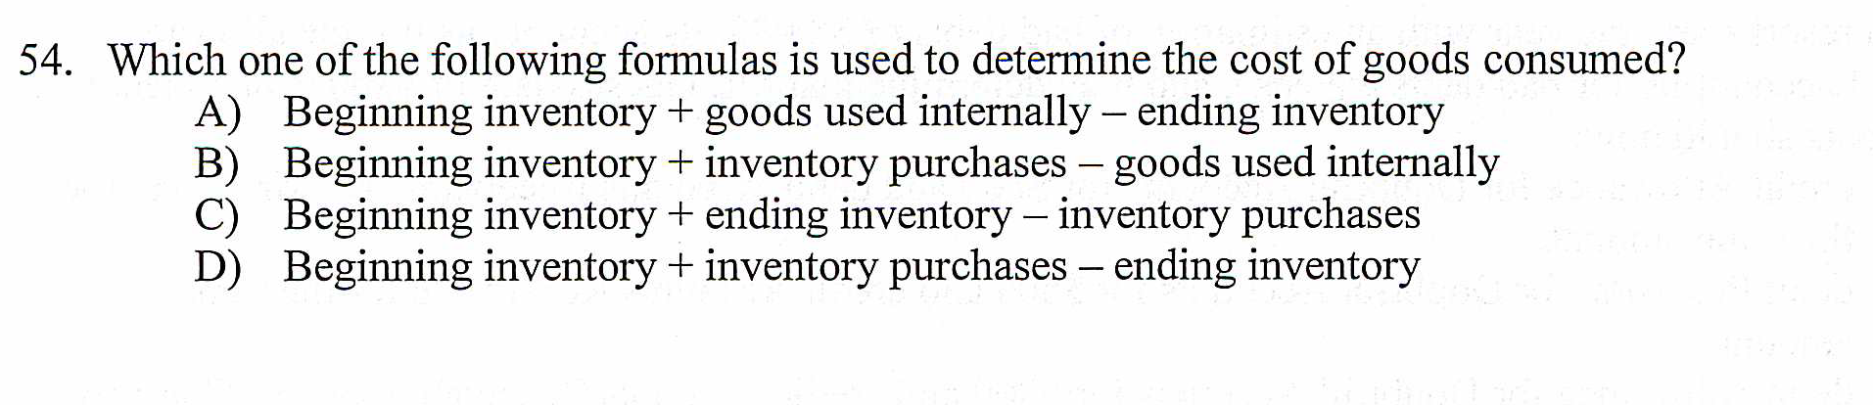
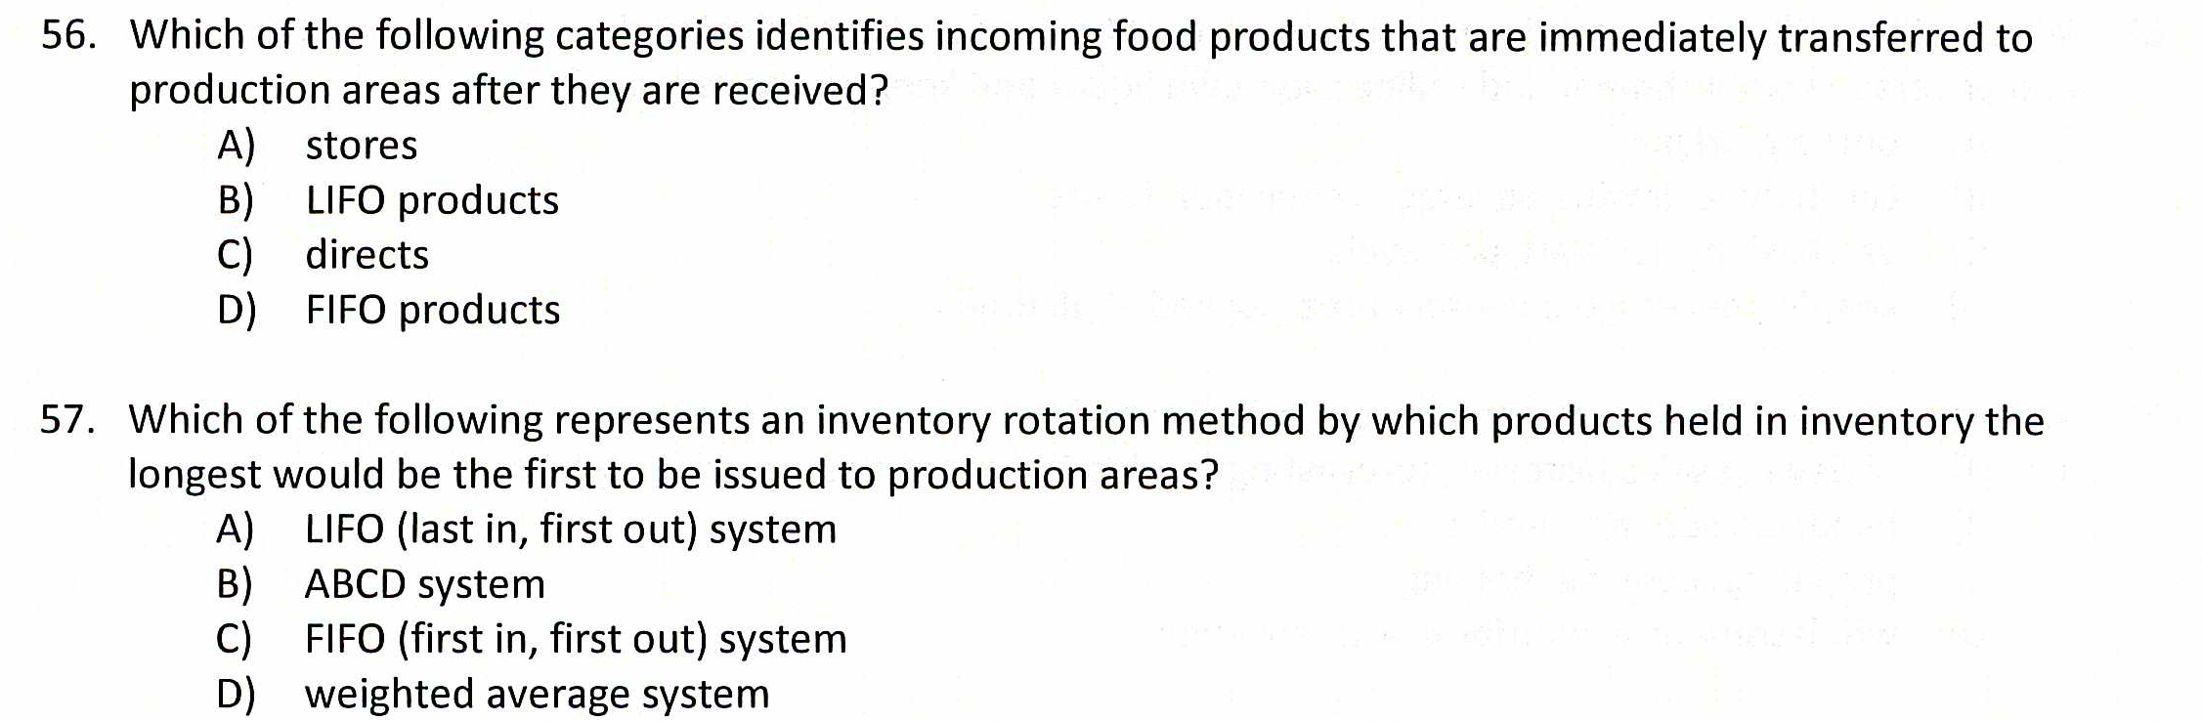
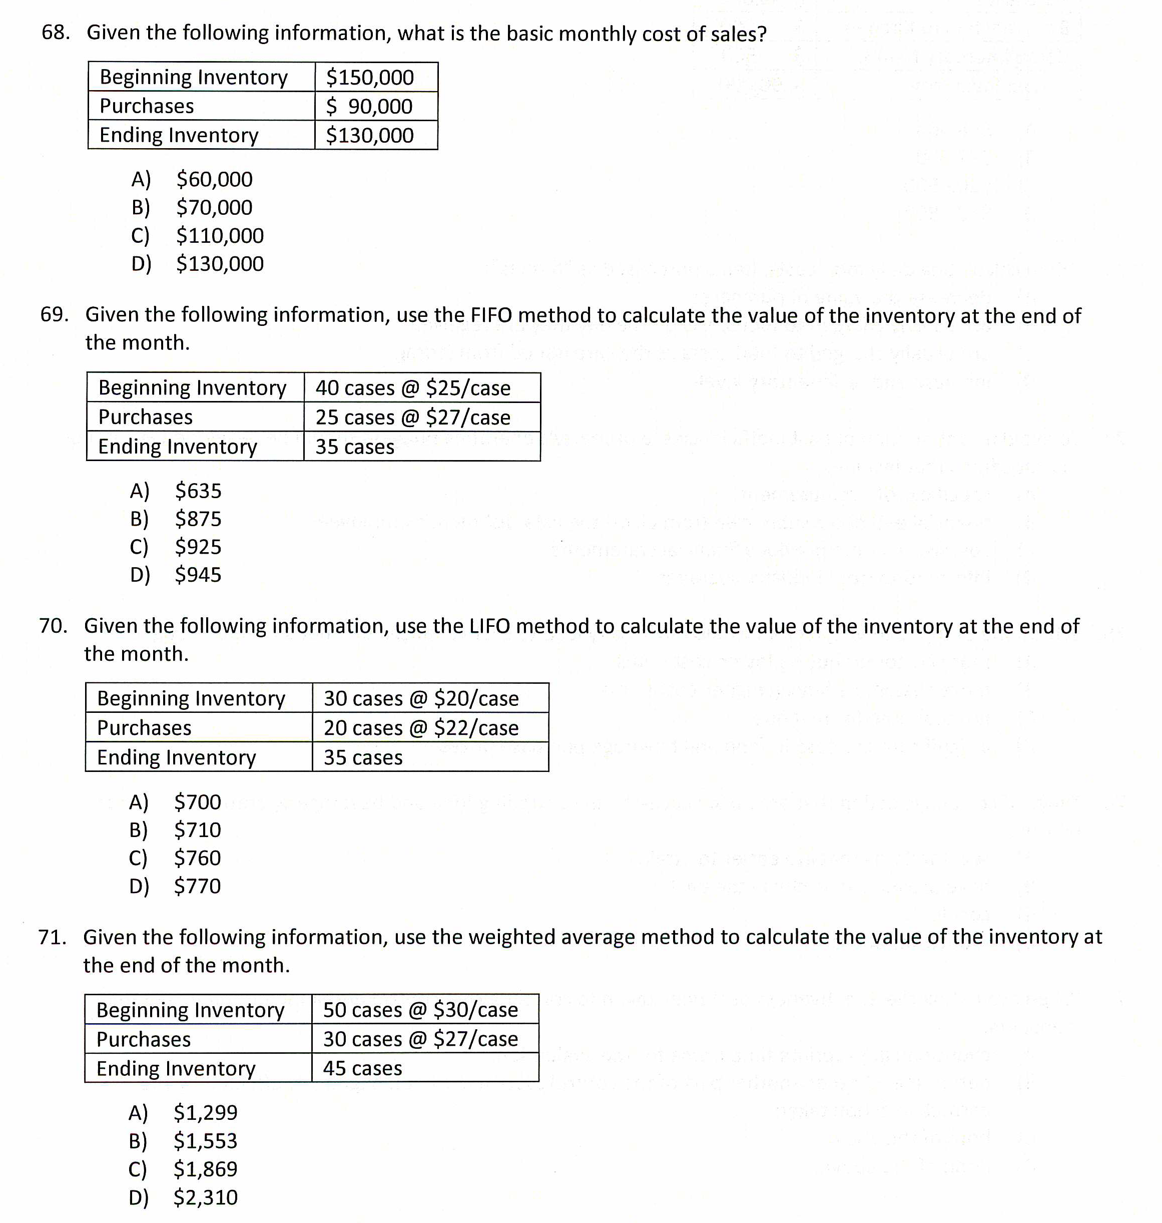

Case 1
The firm has the following current balance sheet accounts.
1. Determine the firm’s total current assets.
2. Determine the firm’s total current liabilities.
3. Determine the firm’s net working capital.
Cash $ 10,000
Accounts Receivable 200,000
Accounts Payable 50,000
Inventory 20,000
Income Taxes Payable 30,000
Prepaid Expenses 10,000
Accrued Expenses 40,000
Current Portion—Long–Term Debt 100,000
Wages Payable 30,000
Marketable Securities 25,000
Allowance for Doubtful Debts 5,000

Case 2
calculate the cost of production outflows and ending inventory by specific identification method, if
Date of purchase | Amount of purchase | Production outflow | Ending inventory
16.01 | 20*$3 | 3*? | ?*?
20.01 | 18*$3.5 | 10*? | ?*?
1.02 | 16*$3.8 | 4*? | ?*?
15.03 | 14*$3.6 | 2*? | ?*?

Case 3
calculate the cost of production outflows and ending inventory by weighted average method
Date of purchase | Amount of purchase | Production outflow | Ending inventory
16.01 | 20*$3 | 3*? | ?*?
20.01 | 18*$3.5 | 10*? | ?*?
1.02 | 16*$3.8 | 4*? | ?*?
15.03 | 14*$3.6 | 2*? | ?*?

Case 4
calculate the cost of production outflows and ending inventory by FIFO method
Date of purchase | Amount of purchase | Production outflow | Ending inventory
16.01 | 20*$3 | 3*? | ?*?
20.01 | 18*$3.5 | 10*? | ?*?
1.02 | 16*$3.8 | 4*? | ?*?
15.03 | 14*$3.6 | 2*? | ?*?

Case 5
calculate the cost of production outflows and ending inventory by LIFO method
Date of purchase | Amount of purchase | Production outflow | Ending inventory
16.01 | 20*$3 | 3*? | ?*?
20.01 | 18*$3.5 | 10*? | ?*?
1.02 | 16*$3.8 | 4*? | ?*?
15.03 | 14*$3.6 | 2*? | ?*?

