Lesson 8
Calculate the sketching following functions:
a) | $$y=x^{3}-6x^{2}+9x$$
b) | $$y=\frac{x^{2}}{x-1}$$
c) | $$y=x^{2}-4x+5$$
Extreme of function
The second derivative may be used to determine local extrema of a function under certain conditions. If a function has a critical point for which f′(x) = 0 and
- the second derivative is positive at this point, then f has a local minimum here.
- the second derivative is negative at this point, then f has a local maximum here.

Find the maximum of total revenue function
.
Find the minimum of total cost function:
.

Find the maximum of the profit function:
.
Find the maximum of total revenue function:
.

At what point does the function have a local minimum (the first question) resp. maximum (the second question)?
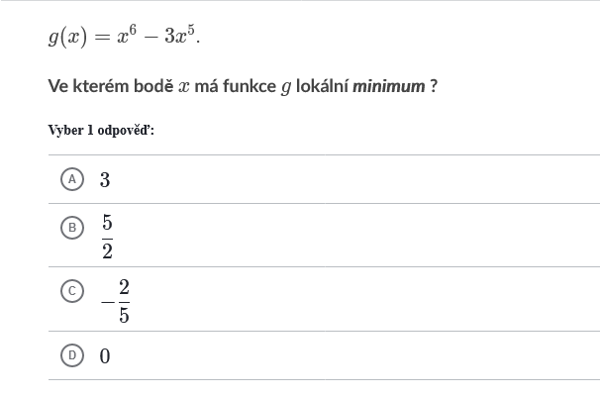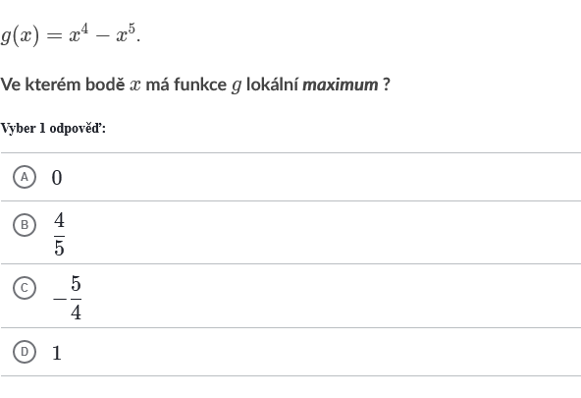
At what point does the function have a local minimum?
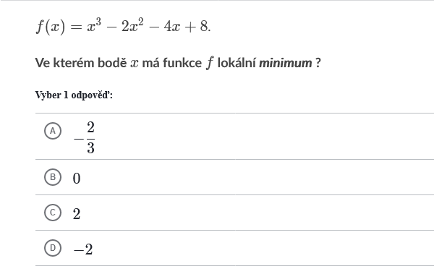

At how many points does the function g have a local minimum and the function f a local maximum?
