Mathematics in Economics – lecture 2
- Domain of a function of the form: (function with linear expression)
- $f\left(x\right)=\frac{1}{2x-8}$

- $f\left(x\right)=log\left(4x-8\right)$

- $f\left(x\right)=\sqrt{-3x+4}$

- Domain of a function of the form: (function with quadratic expression)
Firstly, we must decompose this expression into a product.
We can use the formula $a^{2}-b^{2}=\left(a-b\right)\left(a+b\right)$.
$$9-x^{2}=$$
$$x^{2}-16=$$
We can factor out: $x^{2}-5x=$
$${4x-x}^{2}=$$
Solving the quadratic equation: $x^{2}-7x+10=$
$$x^{2}+10x+21=$$
Than we are going to solve quadratic inequation:
1) decomposition of expression into product
2) find zero points
3) find out what sign it takes in given interval (We choose number from interval and substitute it into the expression)
$$x^{2}-36≥0$$

$$7x-x^{2}<0$$

$$x^{2}+8x+15≤0$$

Solve the domain of functions:
- $f\left(x\right)=\frac{1}{x^{2}-25}$

- $f\left(x\right)=log\left(6x-x^{2}\right)$

- $f\left(x\right)=\sqrt{x^{2}-5x+4}$

The derivative of a function (Derivatives of elementary functions)
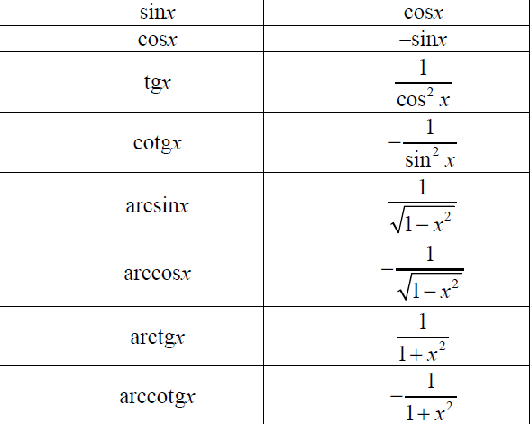

The basic rule is to put the exponent before the expression and then reduce the exponent by one.
$$\left(2x^{5}\right)´=$$
$$\left(5x^{4}-3x^{2}+7x-11\right)´=$$
$$\left(3x^{-4}-2x^{-3}+8x+5\right)´=$$
$$\left(3sinx+4cosx+5lnx+6e^{x}\right)´=$$

The rules of differentiation
(multiplication, dividing, composite function)

