**Mathematics in Economics – lecture 2**

1. Domain of a function of the form: (function with linear expression)
2. Domain of a function of the form: (function with quadratic expression)

Firstly, we must decompose this expression into a product.

We can use the formula .

We can factor out:

Solving the quadratic equation:

Than we are going to solve quadratic inequation:

1) decomposition of expression into product

2) find zero points

3) find out what sign it takes in given interval (We choose number from interval and substitute it into the expression)

Solve the domain of functions:

**The derivative of a function (Derivatives of elementary functions)**



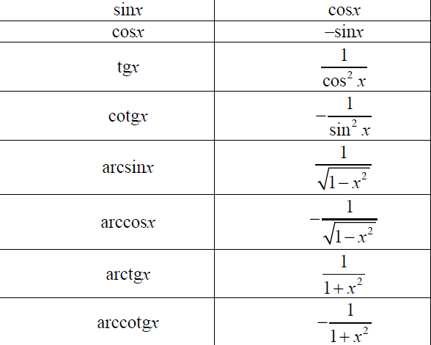

The basic rule is to put the exponent before the expression and then reduce the exponent by one.

**The rules of differentiation**



(multiplication, dividing, composite function)









