Mathematics in Economics – lecture 9

Indefinite integral

Integration is a reverse procedure to differentiation.

Notation:

Legend: $∫$…. Integration sign – indefinite integral; f(x) …. Integrated function;

F(x) … antiderivative of f(x); …C …. Integration constant

Indefinite integral is a linear operator:

We compute integrals with the use of formulas above, and with the use of the table of elementary integrals:

Indefinite integral – elementary integrals
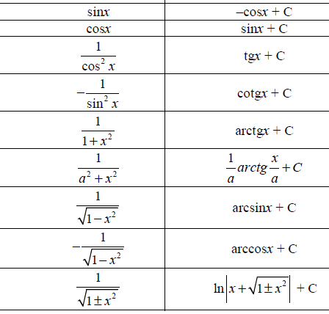

Indefinite integral - examples
1) $\int{\left(6x^{2}+\sqrt{x}\right)}dx=$

2) $\int{\left(2x^{2}+x-15\right)dx=}$

$$3) \int{\left({6x}^{3}+7x^{2}-6x+3\right)dx=}$$

$$4) \int{\left(3x+1\right)\left(4x-1\right)dx=}$$

5) $\int{{\left(2x+3\right)}^{2}dx=}$

6) $\int{\frac{4x^{3}+3x^{2}-5x}{x^{2}}dx=}$
7)

8)
9)
10)

Indefinite integral – integration methods
For more complicated integration we use suitable integration methods:
- Substitutions
- Method per partes
All these methods will be demonstrated on examples.

- Integration by a substitution
We use a substitution typically in the following cases:
- When an integrand contains an internal function.
- When an integrand contains lnx or exp(x).
- When an integrand contains goniometric functions.
- When an integrand contains square roots.

Problem 1
A note: We substitute not only an integrand, but also dx!

Problem 2

Problem 3

Problem 4

Problem 5

Problem 6 Usually, we substitute (square roots).

Problem 7
HOMEWORK
A]
B]
C]
D]
E] F]
- Integration by parts (per partes method)
Per partes method (integration by parts) is used for integration of a product of two functions.
Let u(x) and v(x) be two functions. Then, we obtain:
The last formula is “per partes“ formula.
Problem 1
Note: a choice of u and v´ is important. An incorrect choice leads to a growing difficulty of a problem.

Problem 2

Problem 3

HOMEWORK
A] $\int{\left(2x+1\right).e^{x}dx }$
B] $\int{x^{2}.lnxdx}$
C] $\int{3x.cosxdx}$

