**Mathematics in Economics – lecture 9**

**Indefinite integral**

Integration is a reverse procedure to differentiation.

Notation:

Legend: …. Integration sign – indefinite integral; *f*(*x*) …. Integrated function;

*F*(*x*) … antiderivative of *f*(*x*); …*C* …. Integration constant

Indefinite integral is a linear operator:

We compute integrals with the use of formulas above, and with the use of the table of elementary integrals:

**Indefinite integral – elementary integrals**



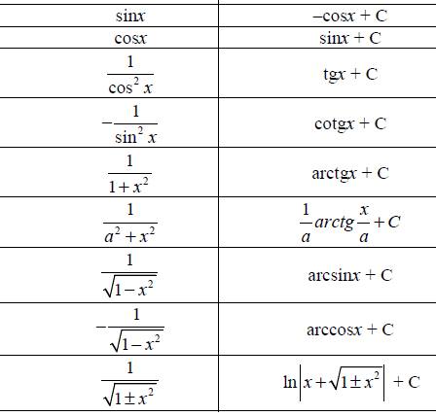

**Indefinite integral - examples**

1)

2)

5)

6)

**7)**

8)

9)

10)

**Indefinite integral – integration methods**

For more complicated integration we use suitable integration methods:

* Substitutions
* Method per partes

All these methods will be demonstrated on examples.

1. **Integration by a substitution**

1)

2)

3)

4)

5)

6)

7)

**HOMEWORK**

A]

B]

C]

D]

E] F]

1. **Integration by parts (per partes method)**

Per partes method (integration by parts) is used for integration of a product of two functions.

Let *u*(*x*) and *v*(*x*) be two functions. Then, we obtain:

The last formula is “per partes“ formula.



Note: a choice of *u* and *v´* is important. An incorrect choice leads to a growing difficulty of a problem.

2)

**HOMEWORK**

A]

B]

C]