**NAME(S):………………………………………………………………………………………**

**Starbucks in China and the differences in the use of marketing communication tools**

**ACTIVITY/TASK**

China is too big a market for U.S.-based companies to ignore. While it presents a very different culture – along with marketing challenges that accompany that culture – many companies have been working hard on expansion into the growth market. In January 1999, Starbucks entered the Chinese mainland market by opening its 1st store in the China World Trade Building, Beijing. Starbucks currently operate more than 6,000+ stores in over 230 cities in the Chinese mainland, employing more than 60,000 partners.

China is not known for its coffee consumption. Starbucks has been adjusting its menu to carry more tea drinks as well as local food items such as Hainan chicken and rice wrap, shredded ginger pork panini, and red bean frappaccios.

In addition to food changes, the company also has to address cultural issues in China. For example, while the U.S. has a “grab and go” mentality to coffee, Chinese customers tend to linger for hours over food and drink. Starbucks is viewed as a place to socialize; most Chinese visit in large groups or pairs, requiring larger community tables, couches and armchairs. Starbucks’ baristas also need to teach customers about the products and drinks.

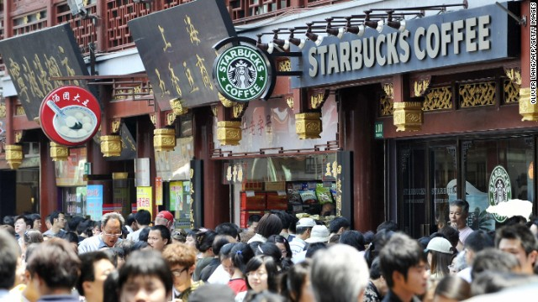

**QUESTIONS**

1. What attributes do companies need to successfully navigate different cultures?
2. Search for marketing communication tools which are used by this company in China and then on next various international markets with emphasis on advertising and cultural differences. Remember to mention also your country.
3. What should a Starbucks store in China look like? How should employees act?
4. Discuss key issues that need to be handled with international expansion.