**NAME(S):………………………………………………………………………………………**

1. **QUANTIFIERS OF SERVICES MARKET and distribution strategy**

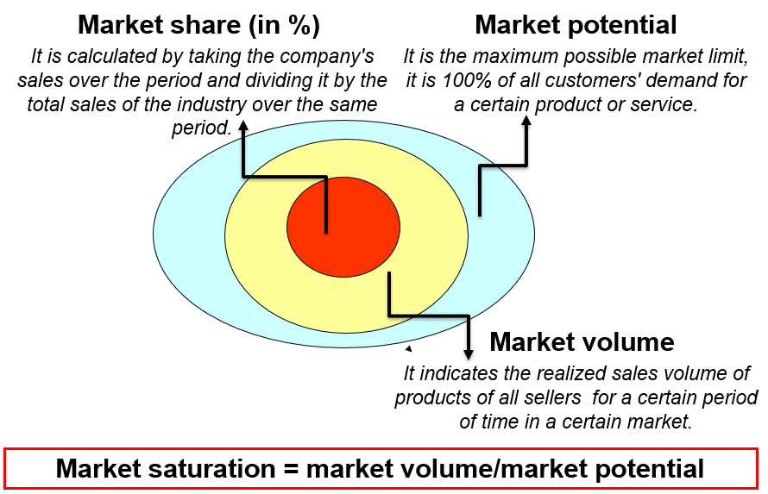

**ACTIVITY/TASK\***

1. Try to find out the market volume and market share in the market of services related to universities in the Czech Republic in a given year. 126 500 students study at all universities in the Czech Republic in a given year. Private university ABC has 6 400 students for now.

**QUESTIONS**

1. What is the market volume of the market of universities in the Czech Republic?
2. What is the market share of private university ABC?
3. What are the typical services of intensive distribution strategy?
4. What are the typical services of selective distribution strategy?
5. What are the typical services of exclusive distribution strategy?