The company manufactures and sells pitchforks. Annually, the company produces 40,000 forks with a total variable cost of CZK 2,320,000. Fixed production costs amount to CZK 1,455,000/year and the price of forks is calculated at CZK 120/piece.

*Determine the cost function.*

C = 3 775 000 CZK

**C = 58*Q + 1 455 000**

The company "O2" offers the service under the following conditions: for a fee of CZK 360/month, the call price for one minute is CZK 1.2/minute. The company "T-Mobile" offers unlimited calls to all networks for a fee of CZK 600 per month.

Task:



1. *Determine in what time interval of calls are the individual offers beneficial?*



1. *Schematically indicate the graphical form of the cost functions*

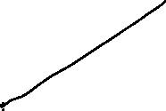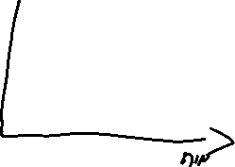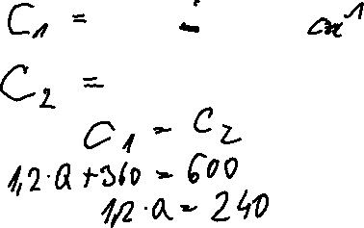

**Case Study: Understanding Variable and Fixed Costs in Manufacturing**

**Background**

ABC Manufacturing is a mid-sized company that produces custom furniture. The company has been in business for over a decade and has seen growth, but recently, the management realized that they were not fully understanding how their costs were affecting profitability. To improve decision-making and efficiency, they needed to break down their costs into **fixed** and **variable** components, and understand their overall **cost function**.

**Problem**

The management team of ABC Manufacturing was struggling with cost control as production levels fluctuated. During months of high demand, their expenses soared, but profitability did not grow as expected. Conversely, in months with low demand, the company still faced high expenses, leading to reduced margins. This inconsistency in costs made it difficult to set prices effectively and forecast profits.

**Cost Structure:**

* + **Rent of factory space**: $10,000 per month



* + **Hourly wages for production workers**: $50 per unit



* + **Salaries of permanent staff**: $15,000 per month



* + **Insurance**: $2,000 per month



* + **Raw materials (wood, hardware, etc.)**: $100 per unit



* + **Shipping and logistics (proportional to production)**: $20 per unit



* + **Depreciation on machinery**: $3,000 per month



1. Calculate total fixed and variable costs for 200 units.



1. Determine the cost function.

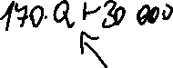

**Scenario 1: Low Production**

In a low production month, the company produced 100 units. The total costs were calculated as:

The average cost per unit:

**Scenario 2: High Production**

In a high production month, the company produced 500 units. The total costs were calculated as:

The average cost per unit: