1. **Marketing plan**

In your marketing plan, be as specific as possible; give statistics, numbers, and sources. The marketing plan will be the basis, later on, of the all‐important sales projection.

This plan consists on those parts:

* Part I – Market analysis (Environment, Competition, Customer, Company analysis) – done in last lesson.
* Part II – Marketing goals, Marketing Mix (product, price, promotion, place)

**Which goals do you want to achieve?**

…………………………………

……………………………………..

……………………………………….

……………………………………….

………………………………………..

**Marketing mix setting**

Product – pro customer point of view. • What is special about it? What after‐sale services will you give? Some examples are delivery, warranty, service contracts, support, follow‐up, and refund policy.

Price.............. Explain your method or methods of setting prices. What are the pricing, fee, or leasing structures of your products or services?

Promotion – promotional activities...........................................................................................

Will you use methods other than paid advertising, such as trade shows, catalogs, dealer

incentives, word of mouth (how will you stimulate it?), and network of friends or

professionals?

Place – type of distribution, location of store.........................................................................

How do you sell your products or services?

People

* **Part III- Strategy, sales plan (quantity of items, customers)**

What type of strategy you want to use ?

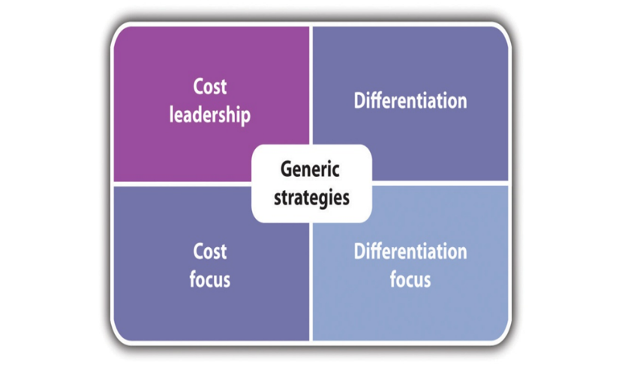

How many items do you plan to sell/offer (or number of customers)?

Who are your customers?

How are you going to provide value to those customers?