Mathematics in Economics – lecture 9

Indefinite integral

Integration is a reverse procedure to differentiation.

Notation: $\int{f(x)dx=F(x)+C}$

Legend: $∫$…. Integration sign – indefinite integral; f(x) …. Integrated function;

F(x) … antiderivative of f(x); …C …. Integration constant

Indefinite integral is a linear operator:

$\int{kf(x)dx=}k\int{f(x)dx}$ $\int{\left[f(x)±g(x)\right]dx=}\int{f(x)dx±\int{g(x)dx}}$

We compute integrals with the use of formulas above, and with the use of the table of elementary integrals:

Indefinite integral – elementary integrals
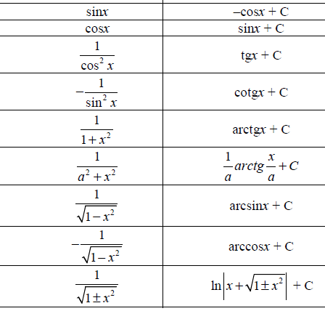

Indefinite integral - examples
1) $\int{\left(6x^{2}+\sqrt{x}\right)}dx=$
2) $\int{\left(2x^{2}+x-15\right)dx=}$
$$3) \int{\left({6x}^{3}+7x^{2}-6x+3\right)dx=}$$
$$4) \int{\left(3x+1\right)\left(4x-1\right)dx=}$$
5) $\int{{\left(2x+3\right)}^{2}dx=}$
6) $\int{\frac{4x^{3}+3x^{2}-5x}{x^{2}}dx=}$
7) $\int{\left(x^{3}+2x^{2}+6x+1\right)dx}=$
8) $\int{\sqrt[3]{x}dx}=\int{x^{\frac{1}{3}}}dx=$
9) $\int{\left(2x+\frac{5}{x}\right)dx}=$
10) $\int{\left(5\sin{x}-2\cos{x}+3^{x}\right)dx}=$

Indefinite integral – integration methods
For more complicated integration we use suitable integration methods:
- Substitutions
- Method per partes
All these methods will be demonstrated on examples.
- Integration by a substitution
1) $\int{{\left(2x+1\right)}^{4}dx}$

2) $\int{e^{2x+3}dx}$

3) $\int{\cos\left(5x-4\right)dx}$

4) $\int{\frac{\ln{x}}{x}dx}$

5) $\int{\frac{5}{x\ln^{2}{x}}}dx$

6) $\int{\sqrt{4x+1}dx}$

7) $\int{x\sqrt{x^{2}-1}dx}$

HOMEWORK
A] $\int{{\left(3x-2\right)}^{4}dx}$
B] $\int{\sin{(}1-5x)dx}$
C] $\int{\frac{\ln^{2}{x}}{x}dx}$
D] $\int{\cos^{4}{x}\sin{x}dx}$
E] $\int{\sqrt{2x+5}dx}$ F]$\int{x\sqrt{x^{2}+2}dx}$
- Integration by parts (per partes method)
Per partes method (integration by parts) is used for integration of a product of two functions.
Let u(x) and v(x) be two functions. Then, we obtain:
$$\left(u⋅v\right)´=u´v+uv´$$
$$uv´=(uv)´-u´v$$
$$\int{uv´}dx=\int{(uv)´}dx-\int{u´v}dx$$
$$\int{uv´}dx=uv-\int{u´v}dx$$
The last formula is “per partes“ formula.
$$1) \int{x⋅e^{x}dx}$$
Note: a choice of u and v´ is important. An incorrect choice leads to a growing difficulty of a problem.

2) $\int{x⋅\ln{x}dx}$

$$3) \int{x\sin{x}dx}$$

HOMEWORK
A] $\int{\left(2x+1\right).e^{x}dx }$
B] $\int{x^{2}.lnxdx}$
C] $\int{3x.cosxdx}$

