

Click and enter the title of the seminar paper

Seminar paper for the course:

Click and enter text.

First and last name: Click and enter your first and last name.

Field of study/program: Click and enter the name of the field/program.

Form of study: Select an item.

Karviná Click and enter the year.

Contents:
Introduction 1
1 Notes on the seminar paper 2
1.1 MS-Word 2
1.2 Structure and formats 2
2 Example of embedded objects 3
Conclusion 4
References 5
List of tables 5
List of figures 5

Introduction
The aim of the seminar paper, the choice of the topic or problem to be solved, the outline of the seminar paper procedure, the choice of tools for solving the problem, etc.

Notes on the seminar paper

MS-Word
Basic video help is available on the official Microsoft website: https://support.microsoft.com/en-us/word.

Structure and formats
Make sure your paper style is consistent, uniform, using a single style of numbered and unnumbered bullets. When writing, use the predefined styles:
- Body text – for the basic style of text paragraphs.
- No Spacing – space-saving style for tables.
- Heading 1
- Heading 2 - don't unnecessarily segment the text.
- Heading 3 – don't unnecessarily segment the text; use it except for large-scale seminar papers.
- Subtitle – use it for better clarity and structure of the text - the heading will not be part of the automatically generated content.
- Quote - for direct quotes in the text.
- Source - style for listing the source under the embedded objects.
- References - style for citation sources: list format.
  - Content
The content is generated automatically. Update content: right-click and select: "Update field".
  - embedded objects
Table and graph captions need to be placed above the object and below the object with the source designation. If you have created a graph or table during the processing of the seminar paper (you are the author), state in the source: "Source: own."
  - References
The method of citing and creating publication sources is described in the Dean’s Instruction No. 03/2024 Editing, publishing and storing final theses.

Example of embedded objects

Table no. 1: Association according to one’s reasons, focus and goals
Country | The signature of the European Agreement | The entry of the Agreement into force
Bulgaria | March 1993 | February 1995
Czechia | October 1993 | February 1995
Estonia | June 1995 | February 1998
Lithuania | June 1995 | February 1998
Poland | December 1991 | February 1994
Source: Fiala and Pitrová (2003, p. 153)

Figure no. 1 Development of mortgage interest rates (2019-2024)
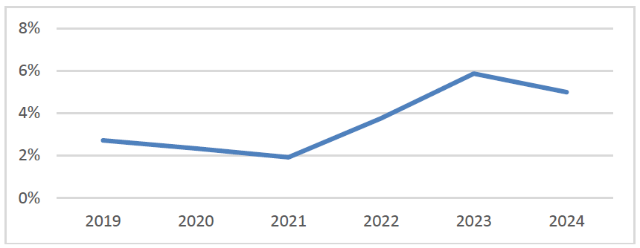
Source: Hyponamiru (26. 8. 2024). Development of mortgage interest rates 2019 – 2024. Retrieved 28. 08. 2024, from https://www.hyponamiru.cz/aktualni-i-historicky-vyvoj-urokovych-sazeb-hypotek/#vyvoj-urokovych-sazebhypotek-v-roce-2024; own calculations

Conclusion
A summary in connection with the introduction: evaluation of the achievement of goals, possibilities for further development, deviations from the procedures originally set out in the introduction, etc.

References
- An, Z., Ghazi, T., & Gonzalez Prieto, N. (2017). Growth and Jobs in Developing Economies: Trends and Cycles (Working Paper 2017/257). International Monetary Fund
- Hindls, R., Hronová, S., Seger, J., & Fischer, A. J. (2007). Statistika pro ekonomy (8. vyd.). Professional Publishing
- Jacobsen, J. P., & Skilman, G. L. (2004). Labour markets and employment relationships: A comprehensive approach. Blackwell Pub.
- Jones, R. (2001). The politics and economics of the European Union: an introductory text. (2nd ed.) Cheltenham: Edward Elgar Publishing.
- Režňáková, M., Karas, M., Srbová, P., Pěta, J., & Michalíková, E. (2024). Performance of Family Businesses in the Specific Conditions of CEE Countries: The Case of the Czech Republic. Journal of Economics, 72(3-4), 169-186. https://doi.org/10.31577/ekoncas.2024.03-04.03
- Václavíková, A., Kolibová H., & Kubicová A. (2009). Labour market and employment policy issues. Opava: Optys.
- Vítková, K. (2022, 17. června). Potraviny zdražují i kvůli suchu v Indii a Číně. Úředníci na Srí Lance si pěstují vlastní plodiny. Hospodářské noviny, 118, 13

Note: the online citation generator can be found at the URL: https://zbib.org/

List of tables
If they are none, delete them including the heading. Generate the list using MS-Word tools ("References" tab of the "Insert Table of Figures" function).

Table no. 1: Association according to one’s reasons, focus and goals 3

List of figures
If they are none, delete including the heading. Generate the list using MS-Word tools ("References" tab of the "Insert Table of Figures" function).

Figure no. 1 Development of mortgage interest rates (2019-2024) 3

